Starry Sky

IGM 602 - Game Design

Game Design Doc

David Liu

Yuanchao Liu

Robert MacLeod

Abhishek Panhale

Soahm Korgaokar

Story and Narrative

Preface

Starry Sky takes place in a timeline where the earth has been blanketed in an eternal night. Darkness corrupted the world and soon will claim every last flicker of light. The remaining settlements of the light race struggle to endure the cold, creeping dark. That is, until one day a person decided to rise up with the courage to challenge the three guardians of the dark. Maybe they would be able to conquer the darkness and vanquish it once and for all, ridding the world of evil and restoring it back to its beautiful, light-filled state.

Story

Starry Sky works with one main story, but the interactions of the characters in the world with the player will be dynamic. Depending on what state the player is currently in, as well as the players actions, characters will be friendly, passive, or hostile to the player accordingly. These interactions may reflect on the player’s final decision at the end of the game, but they do not directly affect any final outcome.

**Zone 1 - Maker’s Choice**

Maker’s choice is the first zone in the world. This zone will be favoring the light side, since this zone is connected to the final light zone--Paradiso. The main feature that outlines this zone is the Forbidden Falls that descend into The River Pass. The Forbidden Falls is a place where the light creatures have been secretly researching on enhancing light swords. The waterfall disguises a path created by the light creatures that allows them entrance into the dark areas of the zone. Other significant areas are the City of Literian, the Volundr Coliseum, and Lone Somber. City of Literian is the light settlement where the player first starts out. It is very well protected, as it is the closest settlement to the light artifact. There are many guards protecting the region, providing a defense that’s seemingly impenetrable. At the Volundr Coliseum, there are high-skilled light warriors that fight in battle against each other to constantly improve their strengths. The Volundr Coliseum is known to be a training ground for knights to turn into true warriors. Lone Somber are where the dark creatures live. This desolated area contains makeshift homes built by the dark creatures. They try to live and survive against the light that’s corrupting over the zone.

**The Light:** The light side in this zone are working towards eliminating the dark creatures of this zone for good. The light creatures are convinced that the dark creatures are the source of all evil, plaguing the land with darkness. Their goal is to eliminate every last dark creature, so they can cover the land purely in light. With their growing power in this zone, they soon would be able to get rid of the darkness for good.

Characters

Lyvalon - The Light Vanguard Chief

Garren - The Blacksmith

Hoven - Literian Scout

Karos - Mighty Vanguard Leader

**The Dark:** The dark creatures are having a rough time being in this zone where the light side is stronger. They’re more on the defensive side, hiding under the safety of the Cliffs of Raven. The Cliffs of Raven are a ring of cliffs that serve as a border of protection, since most light creatures aren’t able to find their way through. The dark creatures are trying to strengthen their numbers in order to fight back against the light and regain control.

Characters

Veshnu - Pack Leader

Kah’vak - Trainer

**Player Choices**

Upon starting the game, the player wakes up inside a room within the City of Literian. They would then be introduced to some of the main characters on the light side. The characters would tell the player about the viciousness of dark creatures and how they would envelop the world in an eternal darkness. From there on, the player would be able to make their own choices, but would be very biased to help the light creatures.

**The Light:** If the player chooses to side with the light side and do the missions they are ordered to do, they would then follow the path to defeat the dark boss and vanquish the darkness in this first zone.

**The Light Consequences:** Once the dark boss is defeated, all of the darkness fades and is overtaken by light. The light creatures invade into Lone Somber and proceed to exterminate every last one of the dark creatures. It appears as very brutal, showing scenes of each creature suffering a painful death.

**The Dark:** If the player chooses to side with the dark side and betray the characters that helped the player, the main characters on the light side, along with the rest of the town, would become hostile and try to kill the player on sight. Dark creatures also would be hostile to the player if they have not transformed into a dark creature already.

**The Dark Consequences:** Once the light boss is defeated, the dark creatures will raid the City of Literian and destroy everything they come across. Scenes will be shown of the important characters dying, as well as every last flicker of light being snuffed out.

**Light and Dark Consequences:** After the zone gets corrupted in either light or dark, the player can choose to still defeat the other boss. The other boss will be much more difficult and stronger. Aside from being an opposing creature, the creatures will not be hostile to the player unless the player begins an attack. The interactions between characters and the player would come off as a feeling of superiority. Conversations would imply that the player did their job and they don’t have much other use in the current zone. If the player manages to defeat both bosses, the land turns into a neutral state, where neither light nor darkness are more than the other.

**Zone 2 - Vicious Valley**

Vicious Valley is the second zone within the game. This zone starts to show the player that the light side isn’t all that it makes itself out to be, while introducing more of the perspective of dark creatures. The zone is balanced between light and dark, which is separated by Death’s Divide--A mountain range that goes as far as the eye can see. The player is more vulnerable to the darkness in this zone and is more likely to transform into a dark creature if the player isn’t careful. The light settlement in this zone is called Holy Haven, which is a kingdom radiating with light that protect the light creatures. On the other side of Death’s Divide is the Corrupted Chasm, where the dark creatures reside and plan on how to break through to destroy Holy Haven. There is also a river that trails through, originating from Limnic Lake, which is the light creature’s main source of water.

**Zone 3 - Ghastly Oblivion**

At this point in the game, the player can come across ruins with murals that depict how the world used to be before light and darkness invaded the land. These ruins also hold the secrets to possessing both the light and dark artifacts, as well as showing the result of bringing them together and destroying both sides. This also would kill the player in the process.

The power of darkness is much stronger in this third zone. Light creatures are at a significant disadvantage, while dark creatures possess an overwhelming amount of power. The dark creatures in this zone are more civilized and are able to think critically, unlike the weaker dark creatures in previous zones. More communication is shown between dark creatures, while light creatures remain in few numbers, having to depend on trusting each other to survive. Once the final zone boss (considering that the player has been defeating 3 bosses on the same side) is defeated, the player would then have access to the final area.

**Final Dark Area - Mortalis**

This is the final zone that players are most likely to encounter on their first play through. If they end up here then it is clear that they have committed to destroying the dark artifact. The stone walls of the cave are corrupted and warped by the overwhelming pressure of the dark artifact. Once the player moves deeper into the cave they find remnants of the facility where the artifact was originally created. Ancient heavy doors lay on the ground from when darkness first erupted from the artifact.

If the player decides to destroy the dark artifact then light is restored to the world and the light creatures will thrive unopposed. If the player has unlocked the option, however, then they can absorb the dark artifact and aim to destroy the light artifact as well.

**Final Light Area - Paradiso**

This area is the player’s confirmation of committing to destroying the light side. There are specific rooms within this place within the sky that show how the dark creatures and light creatures came to be. Murals of the past paint the rest of the picture for what power these light and dark artifacts have over the world. Only directly after finding these murals, the player is given the choice to take the final action of destroying the light artifact.

If the player goes through with destroying the light artifact, darkness then would permanently take over the world. The night would live on forever while the dark creatures can live on, unopposed by any force of light ever again.

Gameplay

Transformation

The core mechanic in terms of gameplay is the Transformation. The Transformation mechanic is basically the transition of a player character between three forms, namely Light Warrior, Dark Creature and Hybrid.

Below are the descriptions for each form:

1. Light Warrior: The completely corrupted form on the Light side.
2. Dark Creature: The completely corrupted form on the Dark side.
3. Hybrid: Any stage in between the Light Warrior and Dark Creature.

The Transformation mechanic depends on the amount of light resource in your sword. The lesser the amount of light in the sword, the more the character is susceptible to darkness. As a Light Warrior, when the player fights with enemies using its sword, some amount of light resource gets consumed from the sword. Consuming more of this light, would make the character more susceptible to darkness which would be visually shown as a slight change in the physical appearance of the character. This would be called the Hybrid form. Now when the sword goes completely out of light resource, the character would become a pure Dark Creature.

It is possible to transition back to a Light Warrior from a Hybrid, however, it is not possible to go back to being a Hybrid or a Light Warrior after the player character has completely transformed into a Dark Creature.

When in Hybrid form, if the player wishes to go back to being a Light Warrior, it can do so in two ways, i) it can go back to the Light Settlement and get the sword replenished with the light resource, holding which removes the dark corruption, ii) the player can consume a Light Refillable resource(explained in the *Light Side Mechanics section*) which replenishes the sword with light resource. Being a Light Warrior/Hybrid, the player character should expect hostile nature from the Dark Creatures. Although, they will be welcomed by the light settlements (unless the hybrid is not very close to being a Dark Creature).

When the player character completely transforms into a Dark Creature, it drops the sword as the sword is totally unlit and hence deals negligible damage. This makes the player character use only the abilities mentioned in the *Dark Side Mechanics section*. Being a Dark Creature, the player character should expect hostile nature from the light warriors as well as dark creatures (if the player character attacks/betrays them in any way).

**Light Side Mechanics**

The gameplay mechanics of the player being a Light Warrior are classified into Core abilities and unlockable abilities.

**Light Warrior Core abilities:**

As a Light Warrior, the basic movement mechanics are more similar to that of a human i.e. slow movement speed and low jumping ability as compared to Dark Creature, as well as Dodging ability. Below table shows a list of Core abilities of a Light Warrior.

|  |  |  |
| --- | --- | --- |
| **Name** | **Purpose/Display** | **Mana Consumption** |
| Walk/Run | Default movement | No |
| Jump | Default movement | No |
| Dodge | Default movement | No |

However, below weapons/resources can be used to enhance those mechanics.

|  |  |
| --- | --- |
| **Weapon/Resource** | **Purpose/Display** |
| Light Sword | Default Weapon |
| Light Refillable | Default movement |
| Stamina | Character Stamina indicator |

1. Light Sword:

This is the default weapon when the player is a Light Warrior. The Light Sword contains the Light resource which gets consumed, when it is used to kill dark creatures.

1. Light Refillable:

It’s a consumable resource that refills the Light resource in the Light Sword. It has a limited usage.

1. Stamina:

This continuously replenishing resource can be used by the player character as a Light Warrior to run faster, and also consume it while performing some of the unlockable abilities.

**Light Warrior unlockable abilities:**

These abilities can be unlocked by using up special experience points. The unlocked abilities can further be upgraded or made stronger by using up additional points. Below are listed the unlockable abilities as a Light Warrior.

|  |  |  |  |
| --- | --- | --- | --- |
| **Name** | **Light Consumption** | **Stamina Consumption** | **Damage Type** |
| Evil Revealing | 4% | No | Multiple targets |
| Mighty Whirl | 2% | 80% | Area |
| Warrior of the Light | 10% | 40% | Single |
| Solar Wind | 3% | 20% | Area |
| Incarnation of the Light | 10% | No | Single/Area |
| Divine Sword | 20% | No | Area |

1. Evil Revealing:

Transmit a light wave around the player character to highlight enemies in the dark. The effect lasts for 20 seconds. Consumed very less amount of light resource from the sword. Upgrading this ability increases the range of the wave and the time taken for the effect to go off.

1. Mighty Whirl:

The player character, holding his sword horizontally, performs fast rotational movement dealing damage to any target within the reach of the sword. Consumes a lot of stamina. Upgrading this ability increases the damage as well as the radius of effect.

1. Warrior of the Light:

Concentrate all the light resource the player character possesses into the blade of the sword, dealing high damage to enemies.

1. Solar Wind:

Perform a horizontal slash dealing area damage and push back small-sized enemies. Upgrading this ability increases the damage as well as persists for longer distance.

1. Incarnation of the Light:

Absorb some amount of light resource from the sword to your body. This allows you to perform area damage attacks due to elevated physical abilities. While performing this attack, the player character emits light making it difficult for dark creatures to come closer. Upgrading this ability makes player character capable of performing the ability by absorbing less amount of light.

1. Divine Sword:

Summon sword clones around the player character. Attack is performed using basic sword slashing moves, however, the clones follow the primary sword and deal damage as well. Upgrading this ability increases the number of cloned-swords which in turn increases the damage.

**Dark Side Mechanics**

The gameplay mechanics of the player being a Dark Creature are classified into Core and unlockable abilities.

**Dark Creature Core abilities:**

Core abilities can only be used by the player if the player has completely transformed into a Dark Creature. As a complete Dark Creature, the physical capability of the player character is boosted i.e. the character possesses unlimited stamina in order to perform an enhanced version of these basic movements. A Hybrid would not be able to use these Core abilities. The player now restores HP and Dark Mana by killing enemies.

The Core abilities, along with some resource indicators, of a Dark Creature are shown in the table below, followed by their descriptions.

|  |  |  |
| --- | --- | --- |
| **Name** | **Purpose/Display** | **Mana Consumption** |
| Melee Claw Slash | Default attack | No |
| High Jump | Default movement | No |
| Speedy Run | Default movement | No |
| Grab Throw | Default attack | No |
| Heal | Default defense | No |
| Health Meter | Character Health Indicator | N/A |
| Dark Mana Meter | Character Mana Indicator | N/A |

1. Melee Clash Slash:

This is the default melee attack. Can have a combo upto 4 hits.

1. High Jump:

A much higher default jump as compared to that of a Light Warrior. Could be combined with other Mana-based abilities.

1. Speedy Run:

A much faster default running ability than a Light Warrior.

1. Grab Throw:

The ability to grab and throw an enemy-pawn in one direction.

1. Heal:

The ability to absorb health points from a particular type of a dark tree.

1. Health Meter:

A UI indicator displaying the health points of the player character at that instance.

1. Dark Mana Meter:

A UI indicator displaying the amount of Mana the player character possesses at that instance. It gets filled as we kill other warriors/creatures.

**Dark Creature unlockable abilities:**

Each ability among the unlockable abilities can be unlocked by killing a certain number of dark creatures possessing the same ability. As different dark creatures will be encountered in different zones, the below table shows the unlockable abilities sub-classified as per the zones. Followed by the table are the descriptions of those abilities.

|  |  |  |  |
| --- | --- | --- | --- |
| **Zone** | **Name** | **Mana Consumption** | **Damage Type** |
| Zone 1 | Dash Claw | No | Area |
| Ground Smash | No | Area |
| Dark Chidori | 80% | Single |
| Fragment Deploy | 30% | 3 - 4 Targets |
| Zone 2 | Underground Strike | No | Single |
| Battle Ram | No | Multiple Targets |
| Rage Form | 100% | Single |
| Black Thunder | 50% | Area |
| Zone 3 | Monster Tentacle | No | 0 - 6 Targets |
| Corpse Awakening | 40% | Multiple Targets |
| Vicious Void | 60% | Multiple Targets |
| Aura Release | 30% | Area |

1. Zone 1:
   1. Dash Claw:

Dash and Slash claws in an ‘X’ shaped fashion releasing dark strikes in the same direction upto a short distance. Deals area damage in a 60 degree sector.

* 1. Ground Smash:

Smash on the ground toward the front side of the player character, dealing moderate damage and pushing enemies away.

* 1. Dark Chidori:

Fill your claws with a dark mana charge and run towards an enemy to deal melee damage. Has a high amount of damage.

* 1. Fragment Deploy:

Release fragments from your body that stick to the enemy’s body and distracts them for 3 seconds, making you attack them easily.

1. Zone 2:
   1. Underground Strike: (Cannot be used by Hybrid)

Ability to stay underground for 4 seconds, pick a target and strike when close to that target. Can move around freely while underground.

* 1. Battle Ram:

Grab an enemy and ram into multiple enemies.

* 1. Rage Form:

Gain extra agility and deal higher damage for 10 seconds. Can only be used once the Mana Meter is full. Mana depletes over time and stops rage when it runs out. This is the only ability, which during its use, cannot allow the player player character to absorb Mana orbs they get after killing an enemy. Also, the player character cannot use other abilities as long as the rage form persists.

* 1. Black Thunder:

Summon black thunder strike on a circular area nearby, with a certain radius, dealing moderate area damage. Electrified enemies are stunned for a short time and zap effect can spread to nearby enemies. Player character can be affected by the initial strike and the zap effect.

1. Zone 3:
   1. Monster Tentacle Release:

Release 6 tentacles to attack up to 6 of the weakest enemies. Can only be used when the player character has less than 30% of health. The ability can be used once every half HP.

* 1. Corpse Awakening:

Spawn 3 to 4 corpses to distract and assist in battle. Only 3 to 4 corpses can be active at a time. Cannot be used outside battle.

* 1. Vicious Void:

Suck enemies into a blackhole for 3 seconds. Small pawn enemies get completely sucked whereas moderately strong enemies are just pulled towards it.

* 1. Aura Release:

Burst a hug black orb to deal damage in all directions. Also, acts a small knockback around the player character.

**Hybrid Form Mechanics**

The player character as a Hybrid would be able to use unlockable abilities of both Light Warriors (by default) and Dark Creatures (with some exceptions). However, it will only be able to use the core abilities of the Light Warriors. A Hybrid would have Stamina, but no Dark Mana. For using Dark Creature unlockable abilities the Hybrid player character would have to use up stamina. Even if it can use abilities from both other forms, the strength of the abilities would completely vary depending one what point of the transformation the player character has achieved.

Level Design

Because this game is basically an open-world game, there are no concrete levels. Instead, this game has three major areas and two minor areas which serve as the levels and the player’s progression is blocked between them. They also divide the whole gameplay and narrative into chucks. Progression between the zones will be linear regardless of the player’s current transformation. Players must progress through the three main zones before unlocking either of the final areas.

This document will show all areas with the assumption that the player is progressing the light side, but each area can be introduced both when the player is light/hybrid or dark.

The initial area where every player starts their game is called Maker’s Choice.

Maker’s Choice

**Map:**

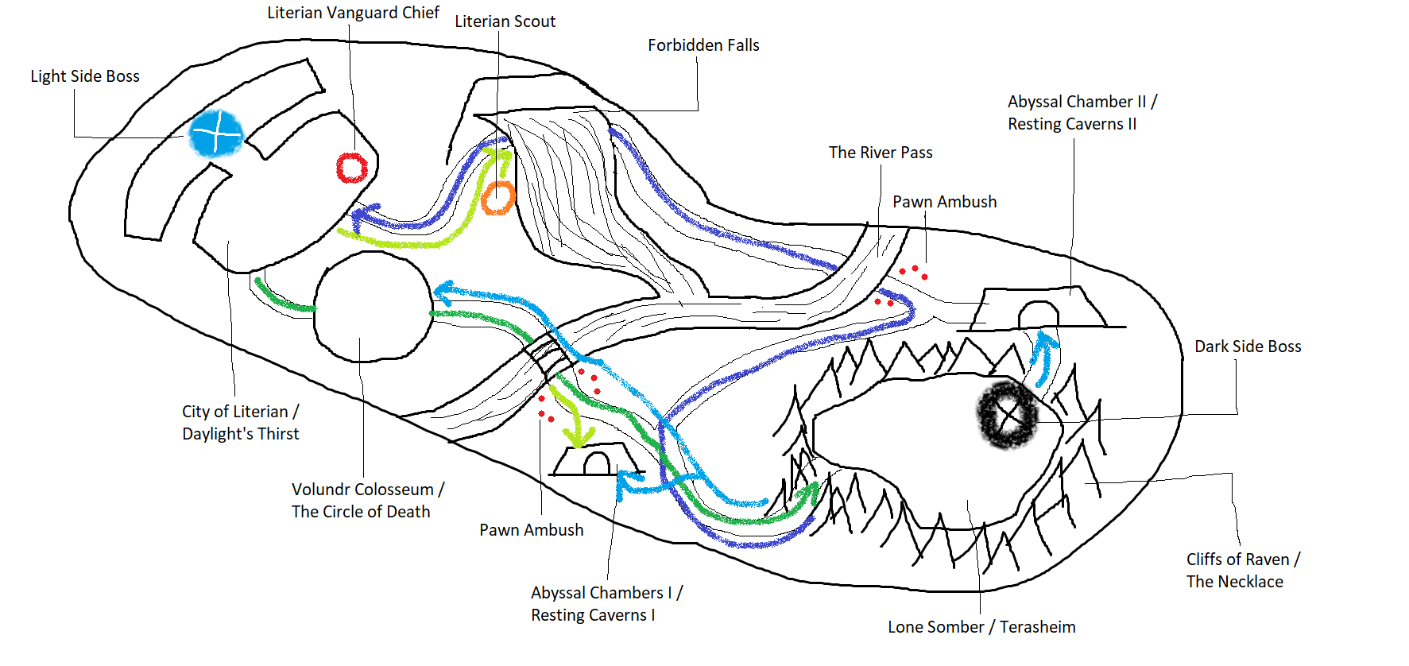

**What the colored arrows on the map denote:**

Dark Green Arrow –> Light side main progression path

Light Green Arrow –> Light Side Quest

Dark Blue Arrow –> Dark side main progression path

Light Blue Arrow –> Dark Side Quest

**Map Brief:**

The above image shows the layout of the first area in the game. This area is where the player first starts in the game. The locations on the map can be accessed by either light or dark side, however the name and feel of the zone would be different for either.

(e.g. <Name as per Light> / <Name as per Dark>).

**Locations:**

City of Literian/Daylight’s Thirst:

**City of Literian:** This is the starting point of the player as a pure *Light* character where the player is given a biased explanation as to how good the *light* side is and that covering the world with *light* would lead to peace. This location is a huge kingdom where the player (as a *light* character) has access to places like the sword generation and charge outlet, and a market shop for buying and selling essential items (and upgraded version of the same). This city acts as a capital for all the *light*-based areas and is the brightest to look among them all. The houses are made of modern materials and are bright-colored giving a fairytale like look. This area also has the Mighty Vanguard formed that consists of highly skilled sword warriors. The boss in this area is the strongest among all the *light* bosses as this area is the closest to the *Light Artifact*. The player, aspiring to be the best *light* swordsman, also meets the Light Vanguard Chief who further motivates the player on his goal.

**Daylight’s Thirst:** This is the objective destination for the player when he is a *dark* creature. Since the player is biased towards the *light* in the beginning, he is most likely to attack the light side after he has been through the other two areas of the game and gets hints of the truth. The player, as a dark creature, would not be able to defeat the *Mighty Vanguard* and/or the *Light* boss as the player’s strength and abilities would be weak as compared to them. As this location is always on a high guard, the *light* warriors would attack the player if he gets closed to the city’s boundary. If the player successfully defeats the light boss, he will get access to the area where the *Light Artifact* is secured.

Lone Somber / Terasheim:

**Lone Somber:** This is the settlement for the dark creatures in the first area. The settlement consists of semi-spherical houses made of wood, mud and dried shrubs. Different low-level pawn monsters can be seen moving around the settlement. Some monsters are seen gathering and discussing over things while some are trying to build things to make the settlement a safer place. Even though the location looks and feels gloomy, some extent of organized behavior can be seen. The pawn monsters are always hostile towards the *light* version of the player. The *Dark* boss at this location is the weakest among the *dark* bosses. Defeating it, gives our player the access to the second area.

**Terasheim:** As the name suggests, this location is the home to the *dark* creatures in the first area. The creatures in this location would not be hostile to the player if they have transformed into a *dark* creature (and that the player hasn’t shown any hostility towards them being a *dark* creature himself). The player would be able to freely roam around the settlement (except for the *dark* boss location) and interact with other creatures. The player once transformed will be able to absorb unique powers of some *dark* creatures after defeating a certain number of the same type.

Volundr Coloseum/The Circle of Death:

**Volundr Coloseum:** This is a structure built by the *light* people similar to the Roman coloseum structure. The construction was done using a strong shiny concrete-type material produced by the *light* capital itself. It is a platform for ambitious *light* warriors to prove themselves to be capable of being a part of the *Mighty Vanguard* formed for this area. The player must go through all the fighting in the colosseum as a part of the main quest, however, shouldn’t be able to defeat all the warriors. The experience gained should be useful in unlocking some new sword abilities. The player also gets a few basic tips on using the sword efficiently by some NPC’s.

**The Circle of Death:** As far as the start of the game is concerned, as a *dark* creature, the player shouldn’t consider going even near this structure as it consists of a lot of highly skilled *light* warriors that together would easily defeat the player. The building is not properly guarded for the same reason. The inside of the building is lit up by the artificial *light* used by the *light* people. Destroying this structure and the warriors inside as a dark creature would give the player a great deal of experience points and some more truth about the *light* side. This location is a side quest for the player as a *dark* creature.

Cliffs of Raven/The Necklace:

**Cliffs of Raven:** These range of cliffs act like barriers for beings other than the *dark* creatures. There is no way to get to the *Lone Somber/Terasheim* except for the two openings in these cliffs. One of those openings can be used in the main quest without any additional requirement, however, the second opening can only be revealed by using the ability achieved by the *Forgotten Falls* side quest. The first opening would consist of encounters with the guarding *dark* creatures. As the player would have to go through a special side quest location for the second opening, there really isn’t an encounter and the player can get entry to the *Lone Somber/Terasheim.* These are the residing places for the black raven-like *dark* creatures that unleash some *dark* aura, making the cliffs visually darker and terrifying. Also, the raven-like *dark* creatures are seen flying around those cliffs in a circular fashion contributing to the darker look.

**The Necklace:** These cliffs function as a protection for the *dark* creatures. Considering that the *dark* creatures in this area are comparatively weak, they highly depend on these cliffs for their safety from outsiders. Both the openings are easily visible to the player as a *dark* creature.

**The River Pass**: This is a river that has kept both the sides separated for years. Nobody knows where this river originates from. As this acts like a boundary, none of the creatures on either side try to cross it and hence stay safe at their own side. The two possible paths for the player to progress as a *light* warrior into the *dark* side have *dark* creatures ready for ambushing anyone beyond the river (red dots shown in the map).

**Forbidden Falls:** These falls are situated on the *light* side of the area. The water over the mountain falls onto the ground through a hug artificial slit that makes it look like a waterfall. This slit was deliberately made, many years ago, by the higher authorities on the *light* side to hide one of the paths to the *dark* side of the area. The *Forbidden Falls* are a side quest for the player as a *light* warrior where the *Literian Vanguard Chief* is looking for the intellectual *Literian Scout* who is secretly working on an upgrade for the light swords to reveal secret dark paths. The *Literian Scout* goes off to give a trial near the falls and trips over it to find himself hanging from a rock. The *Literian Vanguard Chief* orders the player to find the *Literian Scout* and report. After saving the *Literian Scout* from falling, the player is given the upgrade as an appreciation.

As a *dark* creature, *Forbidden Falls* are part of the main quest progression. The secret path is readily accessible to the player as a *dark* creature. The player also needs to watch out for the *light* warriors near the falls.

Abyssal Chambers/Resting Caverns:

**Abyssal Chambers I/II:** *Abyssal Chambers* are a part of a side quest for the player as a *light* warrior. They have a small opening but a huge region once you enter it. Each of them is a region inside a mountain/plateau where different monsters are seen patrolling in guarding a stone containing high amount of *dark* mana. The way to the stone is a bit puzzle-like but not really focused on the puzzle aspect. Entering such location as a *light* warrior would mean fighting against the high number of dark creatures inside. The creatures would call for other creatures as reinforcements. The chamber is designed in such a way that stealth play is possible up to a certain extent.

**Resting Caverns I/II:** This is the holy place for the *dark* creatures. The player feels welcomed as a *dark* creature. The *dark* creatures won’t be hostile towards the player until the player deals some damage to them. The location is a part of a side quest for the player as a *dark* creature and is a good opportunity to increase the amount of *dark* mana he can possess.

Vicious Valley

**Maps:**

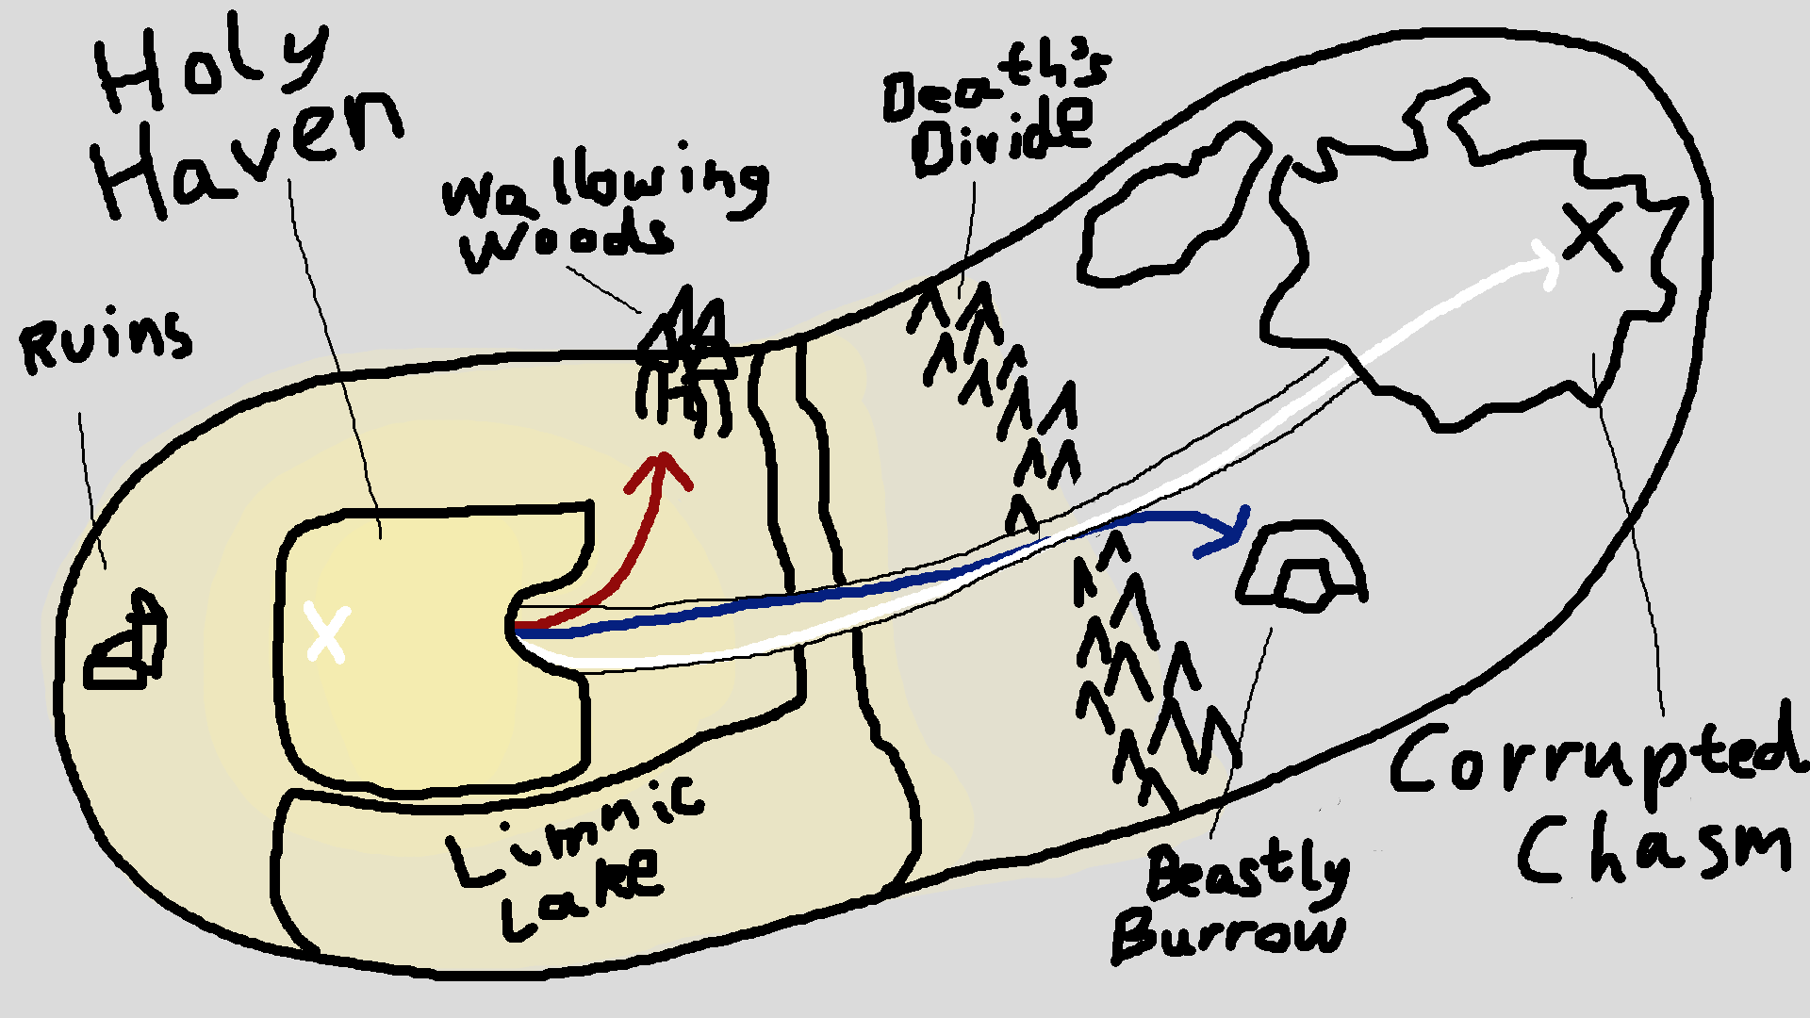

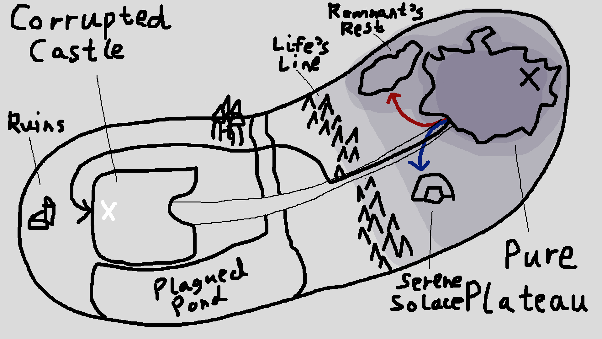 These two maps depict the layout of the second area in the game. The first map is what the map would look like for the player if they are still a light creature. Once the player makes a full transformation into a dark creature, they will see the second map instead. The layout of the maps is shared, but the names and aesthetic feel of the map will change. For example, the mountains splitting the area in half is called “Death’s Divide” for light creatures, but it is named “Life’s Line” for dark creatures. Also, the areas on the map will show the corresponding side the player is on to be “brighter” on the map compared to the other areas.

**Locations:**

Holy Haven/Corrupted Castle

**Holy Haven**: This is the main residence of the player when they are a light creature. Holy Haven is a massive castle that is able to sustain themselves with their own grown food inside and a supply of water from Limnic Lake. The castle is heavily reinforced and has been defending themselves off from the creatures of the dark for years. The player would be able to visit a few key places inside Holy Haven: the blacksmith for upgrading their weapon, a shop for selling and buying items, a few NPCs that will give the player side quests, and the guardian within the deepest parts of the castle, who will give the player the main quest to defeat the guardian of the dark settlement. Other NPCs may walk around and provide either no dialogue or subtle dialogue that isn’t necessary to know for the story.

**Corrupted Castle**: This is the target of attack when the player is a dark creature. All of the light creatures will not act like regular NPCs towards the player, and instead will attack the player when they are in sight. Gates will start to move and lock as the player is spotted within the castle. Reinforcements will be called from other parts of the castle to locate and attack the player. The light guardian will stay within the most protected area, kept safe with the “most skilled” warriors defending the guardian. If the player manages to defeat and destroy the light guardian, they would then be able to progress to the next zone within the game.

Corrupted Chasm/Pure Plateau

**Corrupted Chasm:** The Corrupted Chasm is the “stronghold” of the dark creatures within this area. The area is a wide expanse of den-like houses made of broken trunks, mud, and other decayed materials in nature. Though this look isn’t very appealing, the place should resemble a kind of settlement, showing that the dark creatures are more civilized than originally perceived. Dark creatures will charge immediately at the player as they are spotted, but some of the creatures will make a cry to notify the others of the player’s presence. There will be a dark guardian in the very end of this large area, which once defeated, will allow the player to progress to the next zone within the game.

**Pure Plateau:** The Pure Plateau is a large, flat area that will welcome the player if they are a dark creature (that also hasn’t betrayed the dark creatures). They will be able to interact with other monsters, but just in brief, beast-like greetings and goodbyes rather than full dialogue lines. The player would not be able to approach the guardian though, as there isn’t a strong trust to allow the “lesser creatures” get close enough to the guardian. The player will be warned when they get too close by some strong, dark creatures growling or snarling menacingly that were tasked in protecting the guardian. Upon crossing a certain line, they would then attack the player and the player would not be trusted by the dark creatures anymore.

Limnic Lake/Plagued Pond

**Limnic Lake:** Limnic Lake is the source of water for the light creatures. Since it resides directly beside Holy Haven, they are able to collect the water through their own built-in system along the castle. The lake contains lots of freshwater, hence the name, and covers a wide area, reaching from Holy Haven to one edge of the zone. The lake trails into a river that divides the zone, giving Holy Haven an even more fortified defense.

**Plagued Pond:** The dark creatures find Plagued Pond a cursed body of water. Since the light creatures have made it an essential part in their life, dark creatures fear of it and some believe that the light creatures had plagued the water with their corrupting light. They try to avoid going into the lake’s water, but there isn’t anything that particularly hurts the monsters with the water. It is just considered a kind of “bad voodoo” that should be avoided at all costs.

Beastly Burrow/Serene Solace

**Beastly Burrow:** A large cavern that descends into the ground. The light creatures fear this place and tell stories of how people have vanished and never returned, being either devoured alive or torn to shreds by the dark creatures. Since it is close to Corrupted Chasm, most people don’t dare to try and visit it. Anyone with any common sense should steer clear of this place.

**Serene Solace:** This abandoned den is a well-known place for dark creatures to visit when they want to find a place of peace. They treat the den as a “safe and calm” place that creatures can go to relax. Because this place is important to the dark creatures, they are angered if they catch any light creatures snooping around inside it. Most of the time, the light creature would not survive, or would quickly be chased off to rid their light of their only tranquil place.

Death’s Divide/Life’s Line

**Death’s Divide:** The mountains that separate the lands of evil from the light creature’s lands is called Death’s Divide. These mountains are strikingly visible from Holy Haven, blocking off the other side where the dark creatures reside. It marks the line of where people should definitely turn around and make their way back to the light’s safety.

**Life’s Line:** The mountains have always been a natural protective barrier for the dark creatures. The people of the light are hesitant on crossing past the mountains into their territory, giving their side a safe place. The line splitting the land has spared them their lives. The dark creatures have used this to their advantage, building their ground and slowly growing their numbers.

Wallowing Woods

**Wallowing Woods:** These woods drowned in a sloshy marsh have always been a spot that the light creatures know. Stray dark creatures rarely come into the woods, but it hasn’t been an impossibility to see one lurking in the shadows. There are some trees that have adapted to the marsh, and thus produce a rare sap, which when extracted and heated, can then be melded into the blades of swords to make them more powerful. Some people seek for these special trees, hoping to become stronger in the end.

Remnant’s Rest

**Remnant’s Rest:** This hidden place is where the dark creatures keep those that are deceased. They take their fallen behind the hills, placing their bodies down to fade back into the earth. A dark creature often will mourn for a few hours of someone close they lost, before leaving and hoping to never return to the place again. It isn’t known if any light creatures have found this place, but if they have, then even they did not disturb this resting ground for the dead.

Ruins

**Ruins:** This place contains destroyed structures of stone and brick. Incomplete silhouettes look like they’d shatter upon touch, which would happen if the player decides to try and force something against these remains. It isn’t known by neither dark nor light races on what the structures once were or why they were here. This will foreshadow the neutral race that will come into the story in the third zone.

**Quests:**

There are three quests on each side for this zone. One of them is a side quest that will reward the player while also giving more insight on the other race. The main quest path for the light side is the white arrow, while the main quest path for the dark side is the black arrow. The red arrow represents a necessary quest in order to progress. Though it isn’t shown on the map, regenerating brambles block the path along Death’s Divide/Life’s Line. A skill is needed to break through these brambles, which is obtained by the quests represented by the red arrows.

Light | Red Arrow | Destination: Wallowing Woods

Once the player talks to the blacksmith in Holy Haven, the blacksmith will tell him to fetch some sap from Wallowing Woods. The player would be shown on their map where the location is. The red arrow is the expected path the player should take, though there is nothing preventing them from exploring elsewhere on the light side of the zone. When the player goes into the wallowing woods, they must find a tree that contains the sap. An action for examining each tree will be available during this quest, in which the player may or may not find sap on the examined tree. As the player progresses through the Wallowing Woods, they will encounter a few small dark creatures as enemies. The dark creatures will attack the player when approached. Once the player has obtained enough sap, they should make their way back to Holy Haven and give the sap to the blacksmith. The blacksmith will use the sap to forge the player’s sword and upgrade its power, giving them a new ability for a strong attack. This strong attack can break the brambles that are blocking the way at Death’s Divide.

Light | Blue Arrow | Destination: Beastly Burrow

After completing the Wallowing Woods quest, the player would be able to go on a side quest to Beastly Burrow. The player will be informed that one of the larger dark creatures barely escaped into the Beastly Burrow after losing an attack on some of the light creatures. The player is ordered to go finish the job and bring back its pelt as evidence. The blue arrow shows the expected route that the player will take to get to Beastly Burrow. Once arriving at Beastly Burrow, the player will find several lesser dark creatures trying to protect the large, injured one. This should strike at the player’s morality, because the player will be actively deciding to slay a monster that is at his mercy. The small creatures would barely put up a fight, probably represented as the easy enemies within the first zone. If the player does choose to slay the injured beast, they can then harvest its pelt and bring it back to Holy Haven to claim their reward. The player will be given a new combat skill as one of its rewards.

Light | White Arrow | Destination: Corrupted Chasm

This is the main mission of the story. After obtaining the heavy attack to break through the brambles at Death’s Divide, the player can advance forward to reach Corrupted Chasm. The dark settlement will have waves of enemies prepared for the player to fight. The player has to handle balancing out the enemies he kills with the light remaining in his sword. These dark creatures should also show more tactical combat techniques, such as knowing when to retreat or defending each other to give insight to the player that they have the same intelligence as the light creatures. After the player makes their way through hordes of enemies, they can then face the dark guardian: a boss battle. Once the player defeats the boss, they will vanquish the darkness of this zone and be able to move onto the next one.

Ghastly Oblivion

**Maps:**

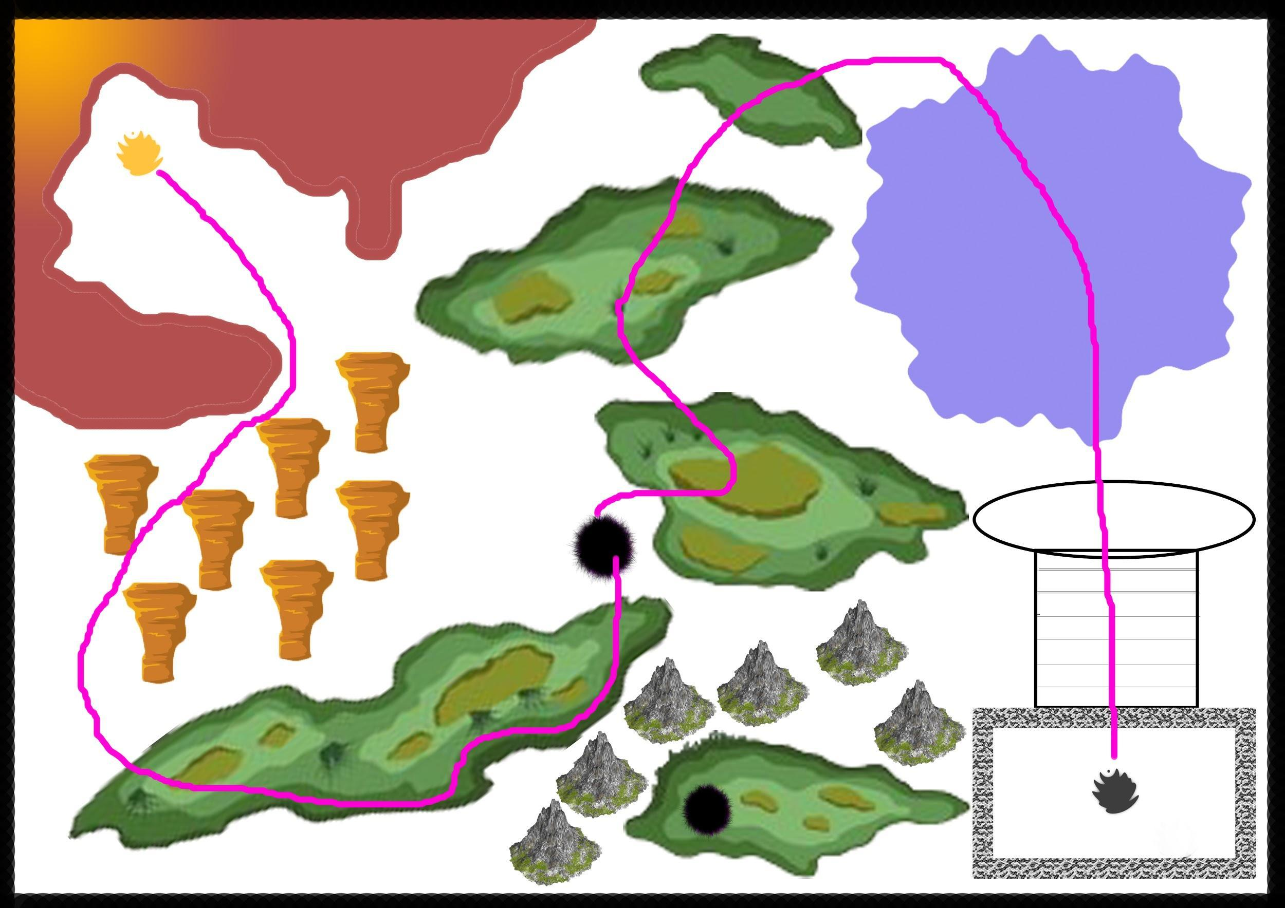

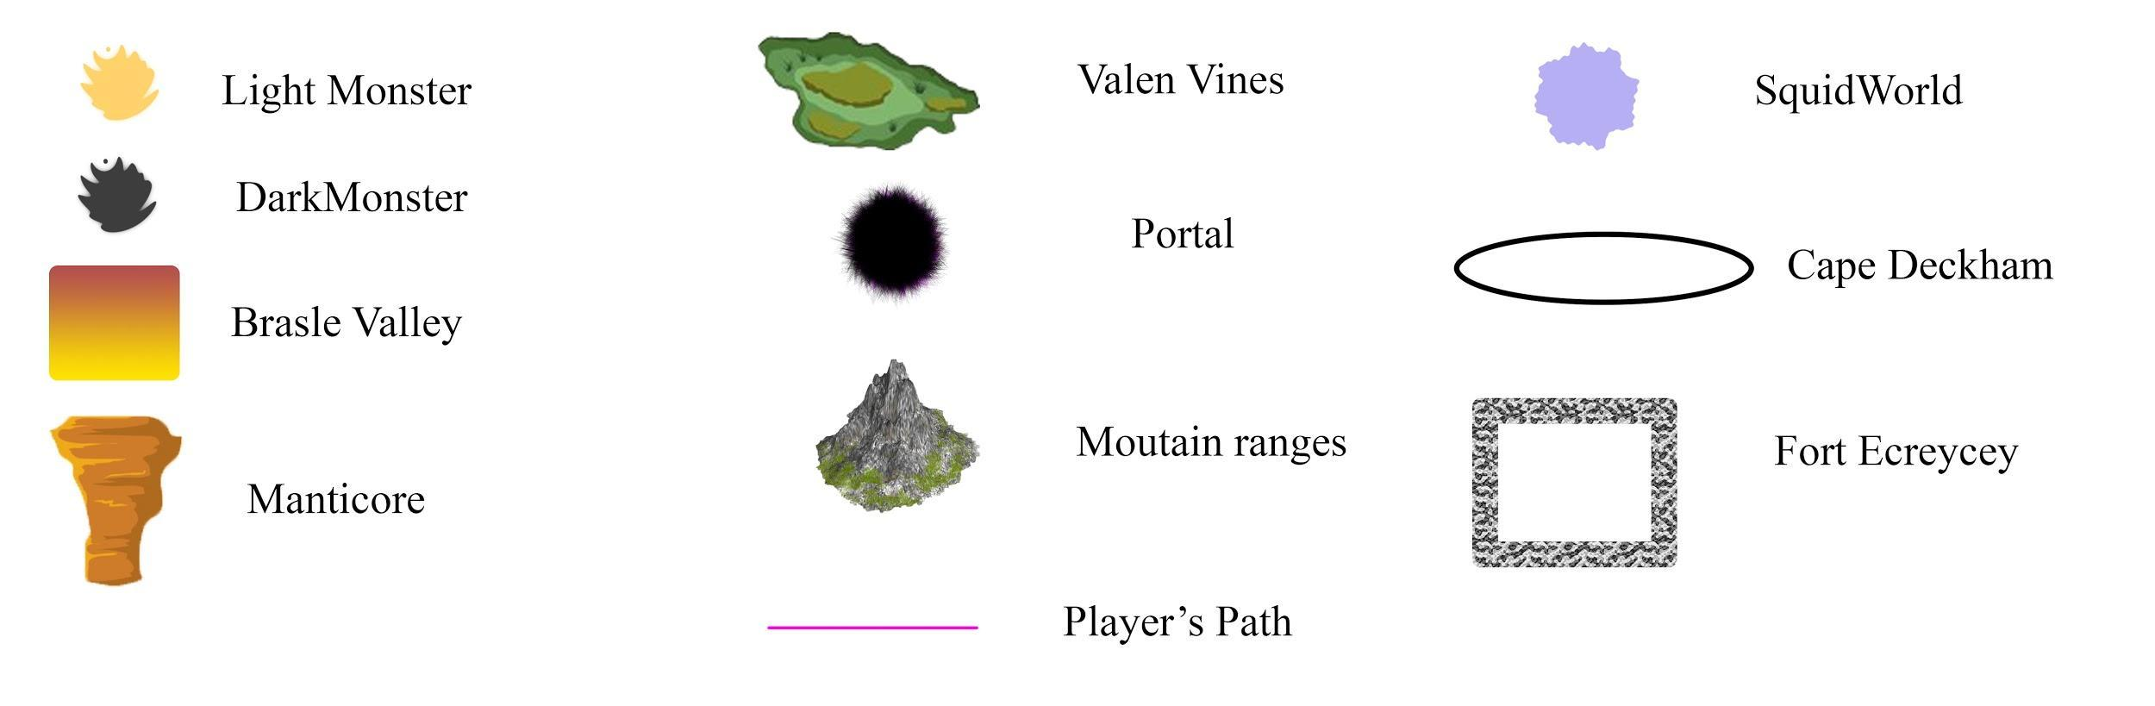

The final zone being the closest to the dark artifact would be the darkest of the open world zones. The zone will have various dark creatures spread all around the level which are hostile towards light creatures. The level will have a greater number of dark corrupted trees for the player to heal themselves as a dark monster. This zone will feel like there never existed any source of light other than some dark creatures that possess some light. There is constant but minimal snow in this zone and has a dark and blues atmosphere. The player can kill the dark as well as the light boss in this zone as they could in the previous zones. All the dark monsters the player has faced in the game by the end of the second zone are in this zone.

**Brasle Valley**

Brasle Valley is located in a central canyon, which is the settlement of light creatures in the third zone. It would be the smallest settlement among the light ones and would also have the blacksmith and shops to upgrade your sword and armour as a light creature. The settlement is located in a central canyon with light creatures guarding the light boss of that zone. The light creatures are at full alert and have ample weapons to defend the settlement. Since this settlement is farthest from the light artefact, the light creatures are weak and comparatively more vulnerable to the dark. The mountains provide cover to the settlements and cover it from almost three sides. The canyons open up to the Manticore through which the player can go to access the zone. There are comparatively lesser light monsters in this zone than there are in other zones. There are small tents and houses for them to live in. The player can look at Fort Ecraycey, from the top of the canyon over the Valen Vines, standing upright on the high mountains piercing through the dark clouds.

**Manticore**

Manticore is an open wide valley between two large cliffs that has multiple platforms in between them for the player to jump across. The valley is too deep for the player to survive if they fall off the platform. The player will face NPCs to gain the gap clearing ability at the Manticore if they are a light monster. The player gains the ability to jump and dash to clear gaps in the game and can use it to clear these platforms. The zones will have various dark monsters attacking the player as they clear the platforms. This area will also have a quest for the player as a dark monster where they will learn how the world will look like if they destroy the dark artefact.

**Valen Vines**

Valen Vines is a long stretch of forest which has a haunted vibe and is located in the center of the zone. The forest consists of many dark corrupted trees which the player can use to heal themselves with. The player will use his ability to clear obstacles like scramble in the forest. There would be various rocks and trees in this zone that the player can use to hit their enemies. The forest would be full of dark creatures wandering around in the cold night. The player would attract these monsters towards them if they use their sword as a light creature. They would be hostile towards the light creatures and even the dark ones if they are suspicious. There would be some unique creatures in the forests that would let out a different kind of mana after they are dead. The player would gain the ability to burst a black orb to deal damage in all directions after killing enough of these creatures. The player would use their detective mode to find the way through the forest. The Vines will have a very dark area which the player can only access if they have completely transformed into a dark monster. The area would be in the dense forests in the vines and would have minimal amount of light coming through the trees. The players can use the trees to perform environment combos while fighting enemies. This area has dark monsters who are controlled by a tree-like looking monster who can awaken them even after they are dead. The player will obtain this ability of corpse awakening after killing that monster.

**Tishmo Murals**

There would be blackhole like portals in these forests that the player can go through. If the player is a light creature, they would end up in a cave and use their sword to find their way out. As they go through the cave they would find huge murals on the walls of these caves which depict the truth about life on this planet. The cave would have a lever in the middle of a dome-like structure and the walls would rotate to reveal how the corruption spread in the world. However, the player would be attacked by dark monsters everytime he moves the lever. The player would understand life was neutral and the light and dark corrupted humans and incorporated the idea into the minds of their creatures that the other side is the evil one. The player would also know how they can absorb the artefact without destroying it. The caves will have small plants and fungi on the walls which are not currently not found in the world.

However, if the player is a dark monster, and they enter the portal they would be first taken to a darker zone in the woods surrounded by monsters. The portal monsters are defensive about their area and attack the player. The player, after defeating these monsters, can use the portal abilities with their mana. After this, the player would enter another portal and go into those caves with the murals.

**SquidWorld**

Squid World is the area at the foothills of the dark boss’ Fort Ecraycey. The area has shallow waters with fish having bioluminescent lures on their head. These fish also resemble a piranha and can attack the player. The corrupted shallow waters of Squidworld will have dark monsters that will have squid-like face with tentacles hanging from its mouth. The player can use the monster tentacle ability as a dark monster and the divine sword after defeating a certain amount of these monsters. The player will unlock the ability to clear gaps as a dark monster at the SquidWorld. SquidWorld also consists of dangerous and violent trees that attack the player if they are in the range of its branches.

**Cape Deckham**

Cape Deckham is a small area at the start of the stairs to the dark boss’ fort. The player will face new and hybrid versions of the monsters in this area they have already faced in the game. The monsters will have increased strength, agility and power. These monsters will attack the player in waves and the player has to kill all the monsters in order to clear the area.

**Fort Ecraycey**

This is the castle of the final dark boss which is located at the top of the mountains and has a long set of stairs to reach the gate. The castle has a long and strong architecture and pierces the clouds that strike lightning over this dark world. The player can see many dragons and huge dark monsters flying over the castle, pretending to save their home from the dangers of the light. The dark boss will be protected by the elite monsters of the dark race. The entire castle would be a maze and have moving stairways which the monsters would move so that the player doesn’t get close to the dark boss. The castle will have monsters guarding it from the outside as well as certain spots in the castle. The player would have to use his abilities he has gained during the game to cross obstacles and find his way to the dark boss.

-When you defeat either all three light bosses or all three dark bosses, the light or dark final area will be unlocked correspondingly.-

Mortalis/Infernus

**Maps:**

**Exterior**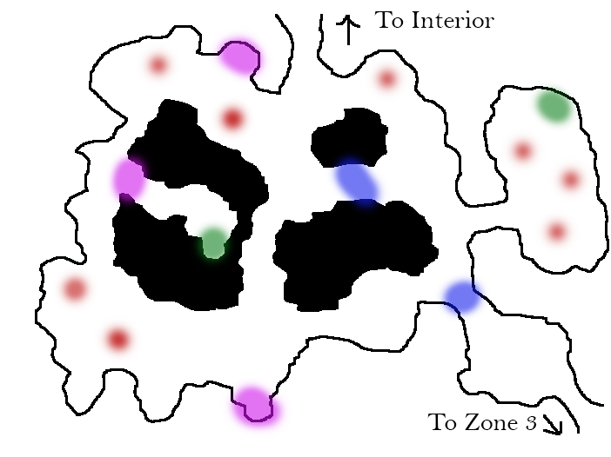

**Interior**

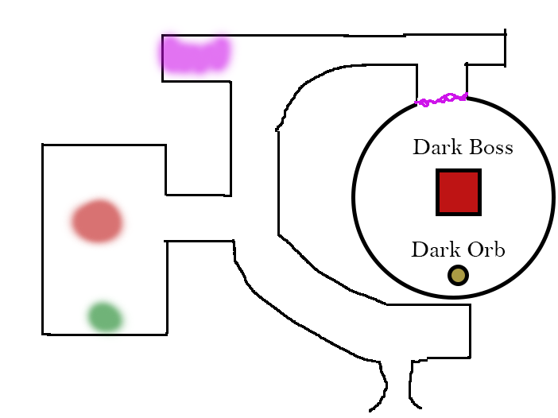

**Map Key**

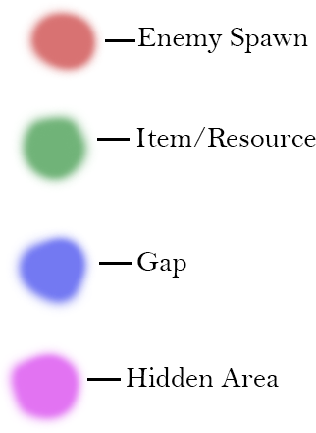

**Introduction:**

Mortalis is the area of the world that has been exposed to the dark energy of the artifact the most; both in terms of intensity and duration.

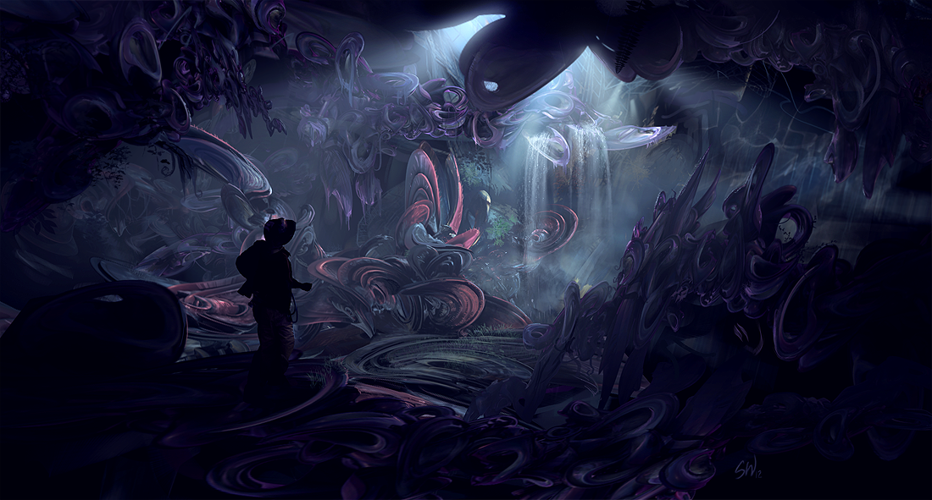

**Exterior:**

The walls of the cave bend and pulsate as if they were alive, and it is hard to tell where one shape ends and another begins in the unnatural darkness. The prolonged exposure to the dark artifact has corrupted everything both alive and otherwise into its purest and darkest form. Enemies here are far stronger than in the previous zones as they have been allowed to grow untouched by the opposing light. That, and the artifact is determined to protect itself from any outside force.

Players who have fully transformed will have no trouble navigating through this place, having already become accustomed to traversing the night. Merely being in the presence of such darkness will keep their Dark Mana replenished. Light creatures, on the other hand, will find themselves constantly in danger of having their light snuffed out. Puddles of dark energy threaten to infect them like a poison and the monsters do not flee in the face of the light the player wields.

As the player progresses further through the cave and towards the howling dark energy, they will stumble upon an area not unlike the ruins they had seen in previous zones....

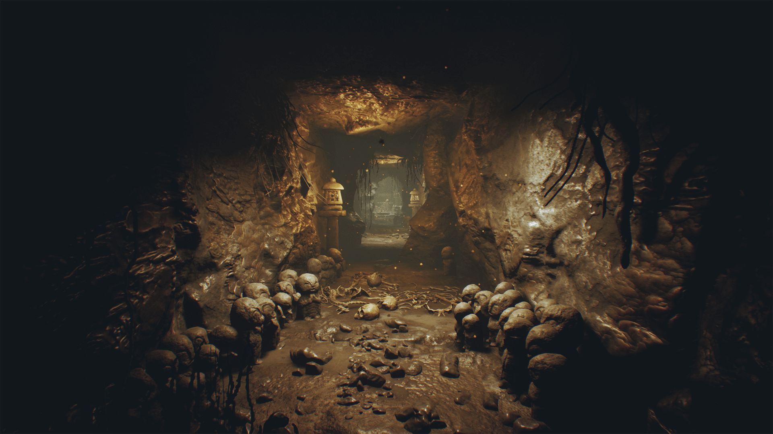

**Interior:**

When they come upon the interior to the final zone, the dark pulsating walls give way to what at one point in time may have been a carefully constructed building. The walls of the facility, though able to resist complete corruption by the artifact, have nonetheless been warped into a haunting vision of their former self.

Much of the building has collapsed or caved-in over the years, but just enough of its former self remains to hint at its true origin; it belonged to the race that came before the eternal night began. A long hallway, energy pushing out of it like a dark wind, leads the the final room containing the artifact.

The containment room no longer resembles any kind of architecture the player has seen before. The walls have been blown outward transforming the room into a large half sphere. It’s as if the force of the artifact alone is what is keeping the room from crumbling down.

Once the dark boss has been slain the the player makes their choice, the building will start to crumble and the player’s fate is determined by what choice they made. If they are dark then they would perish with the rest of the dark creatures. If they are light then they survive to see the world overtaken by light. If they are choosing to destroy both artifacts (and haven’t destroyed the other), then they must escape back to the third zone to continue their journey.

Paradiso/Pandæmonium

**Overall map:**

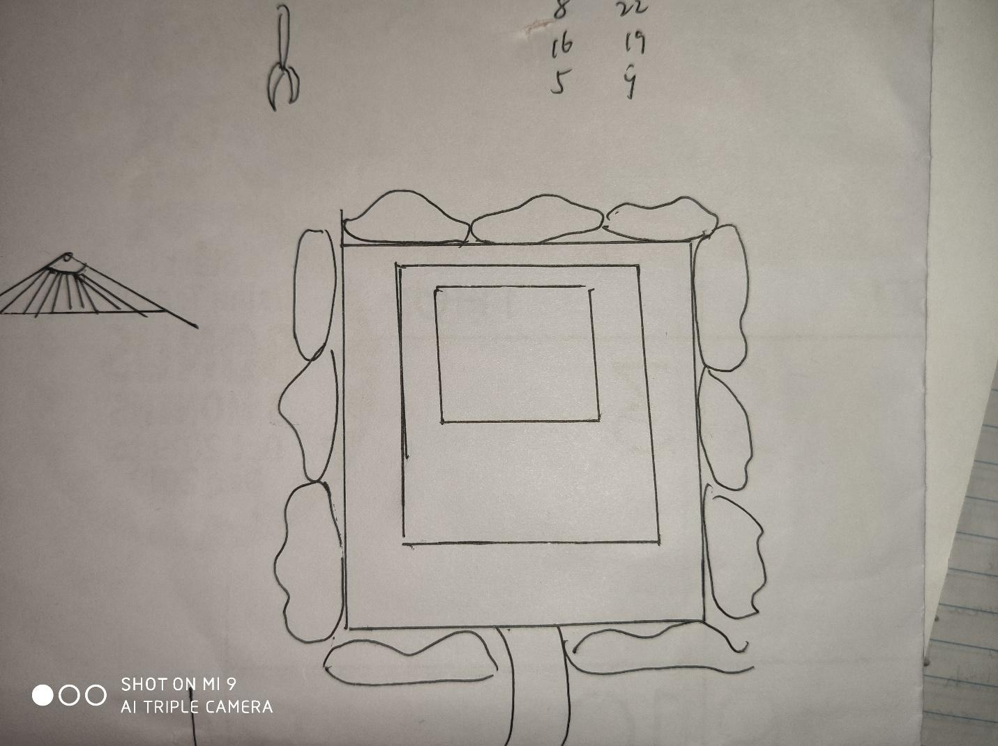

Rainbow Road

**Introduction:**

This place looks like cloudsdale and has an ancient Greek architecture style.

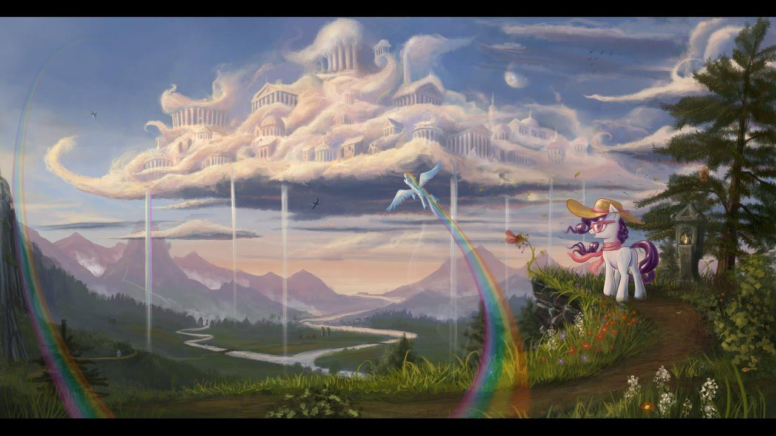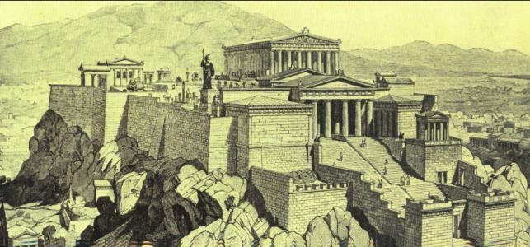

This place is the final and hidden place of light creatures. Originally, it is invisible and floats in the sky in the first zone. When you beat all the three light bosses, this place will be revealed, and you can reach it through the Rainbow Road. Once you step onto the rainbow road, there is no way back-you must finish this place.

Because the light orb hides in this place, it is full of light energy. So, when you play as light or hybrid, your sword will be always full of energy, but your skills which consume light are not effective to creatures in it. When you play as dark, your skills which use dark energy are super effective to creatures, including bosses.

Different from former zones/areas, you don’t have a map of this place initially, because this is a secret place which you have only heard from light/dark tales, but you will gradually “draw” the map along with your path.

**First Floor**:

Stairs(to the second floor)

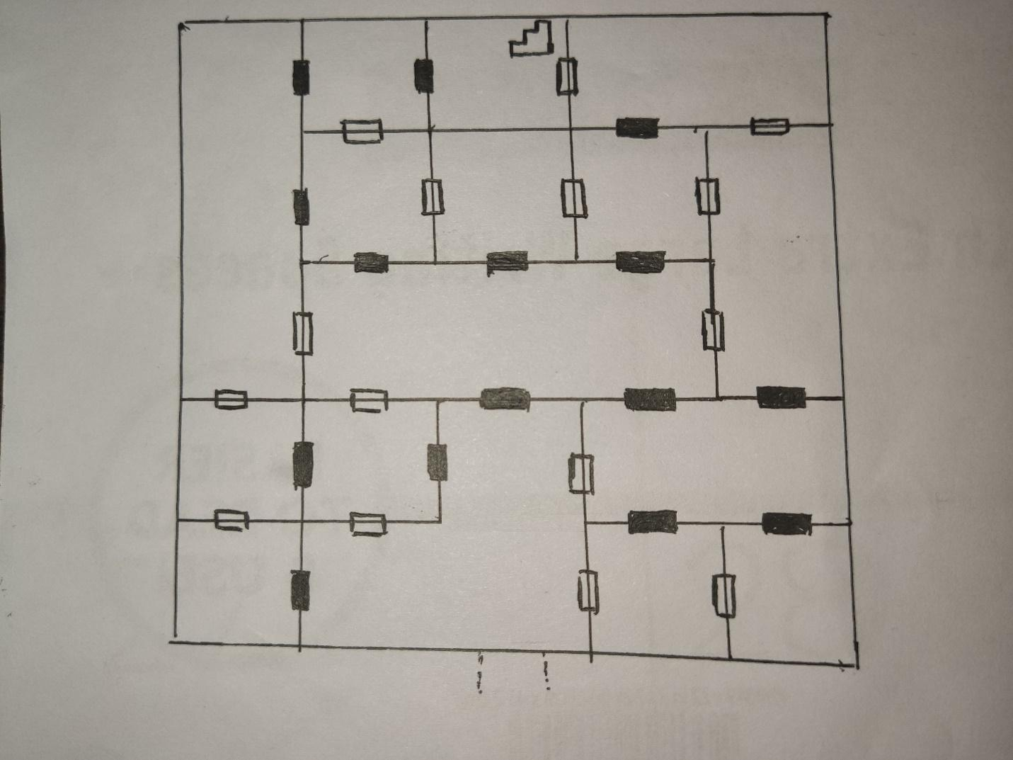

: Light Screen

They serve as doors which dark creatures can’t pass through

: Breakable Wall

They are basically ordinary walls, but dark creatures can break them with their dark power since they lack of light energy.

Possible Paths(Light & Hybrid/Dark)

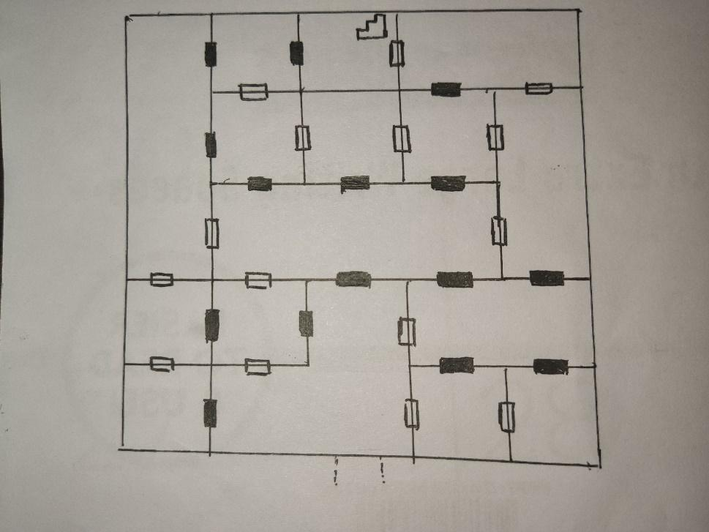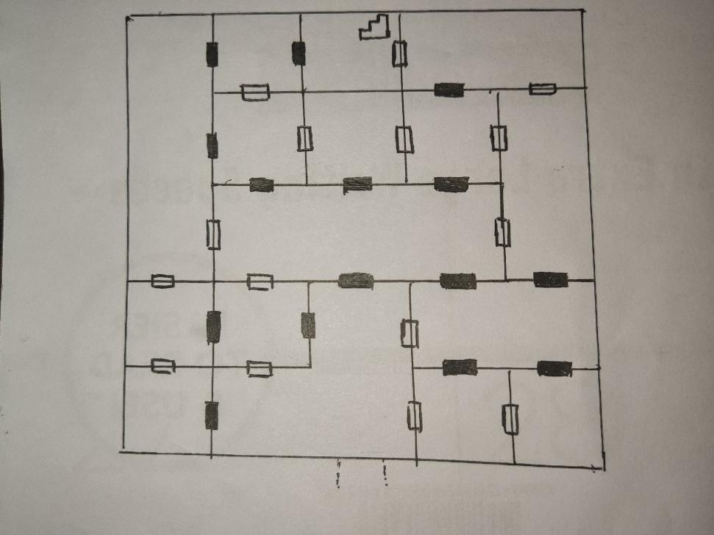

: Light Patrol

Relatively weak light creature(s) which are patrolling around. Players may keep out of their sight and avoid battle.

: Light mini boss

Strong light creature. Players must fight it.

: Treasure Chest

Players can find things inside.

**Second Floor:**

Stairs(to the first floor)

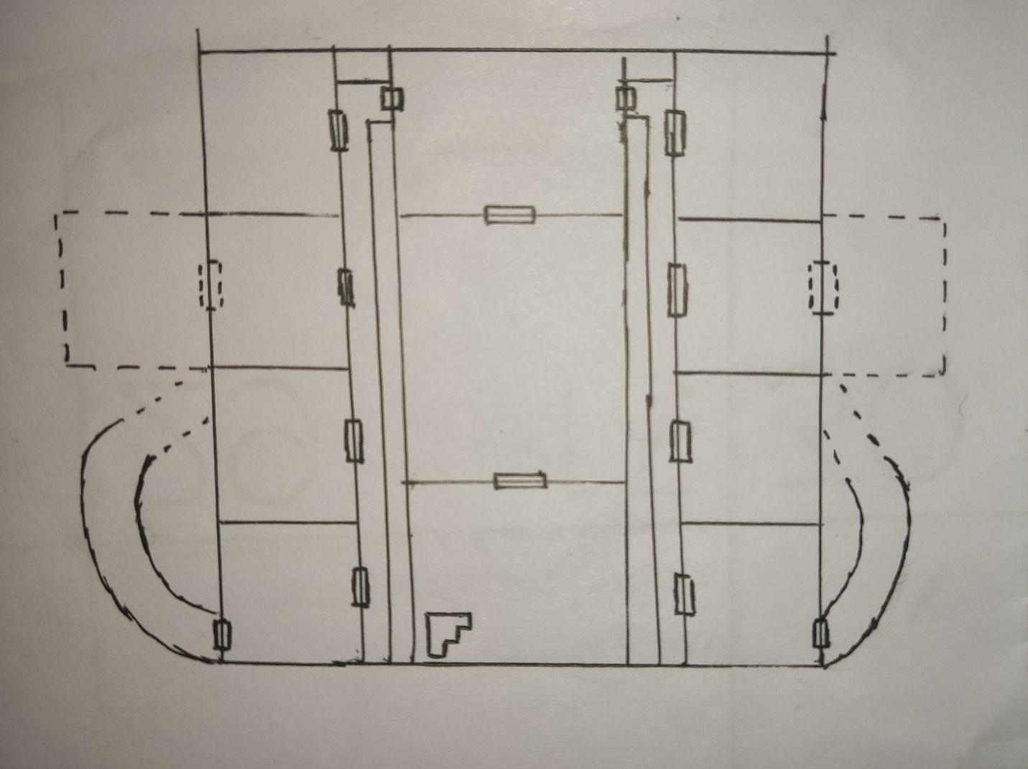

Spiral Rainbow Road(to the third floor)

: Normal Doors

(on the left): It’s a hidden door which you can discover with your “searching” ability when you are PURE light, but it can only be destroyed by the “smashing” ability when you are PURE dark. Inside the room you will find some records about dark creatures. 

(on the right): It’s a hidden door which you can discover with your “searching” ability when you are PURE dark, but it can only be destroyed by the “smashing” ability when you are PURE light. Inside the room you will find part of the true history of light creatures.

White areas: These areas are full of light, and light creatures are nearly invincible in these areas. When you are dark and inside these areas, you will suffer damage constantly.

: Light Patrol

Relatively weak light creature(s) which are patrolling around. Players may keep out of their sight and avoid battle.

: Light mini boss

Strong light creature. Players must fight it.

: Treasure Chest

Players can find things inside.

: Light Archivist

Weak light creature(s) which are writing things in their room.

**Third Floor:**

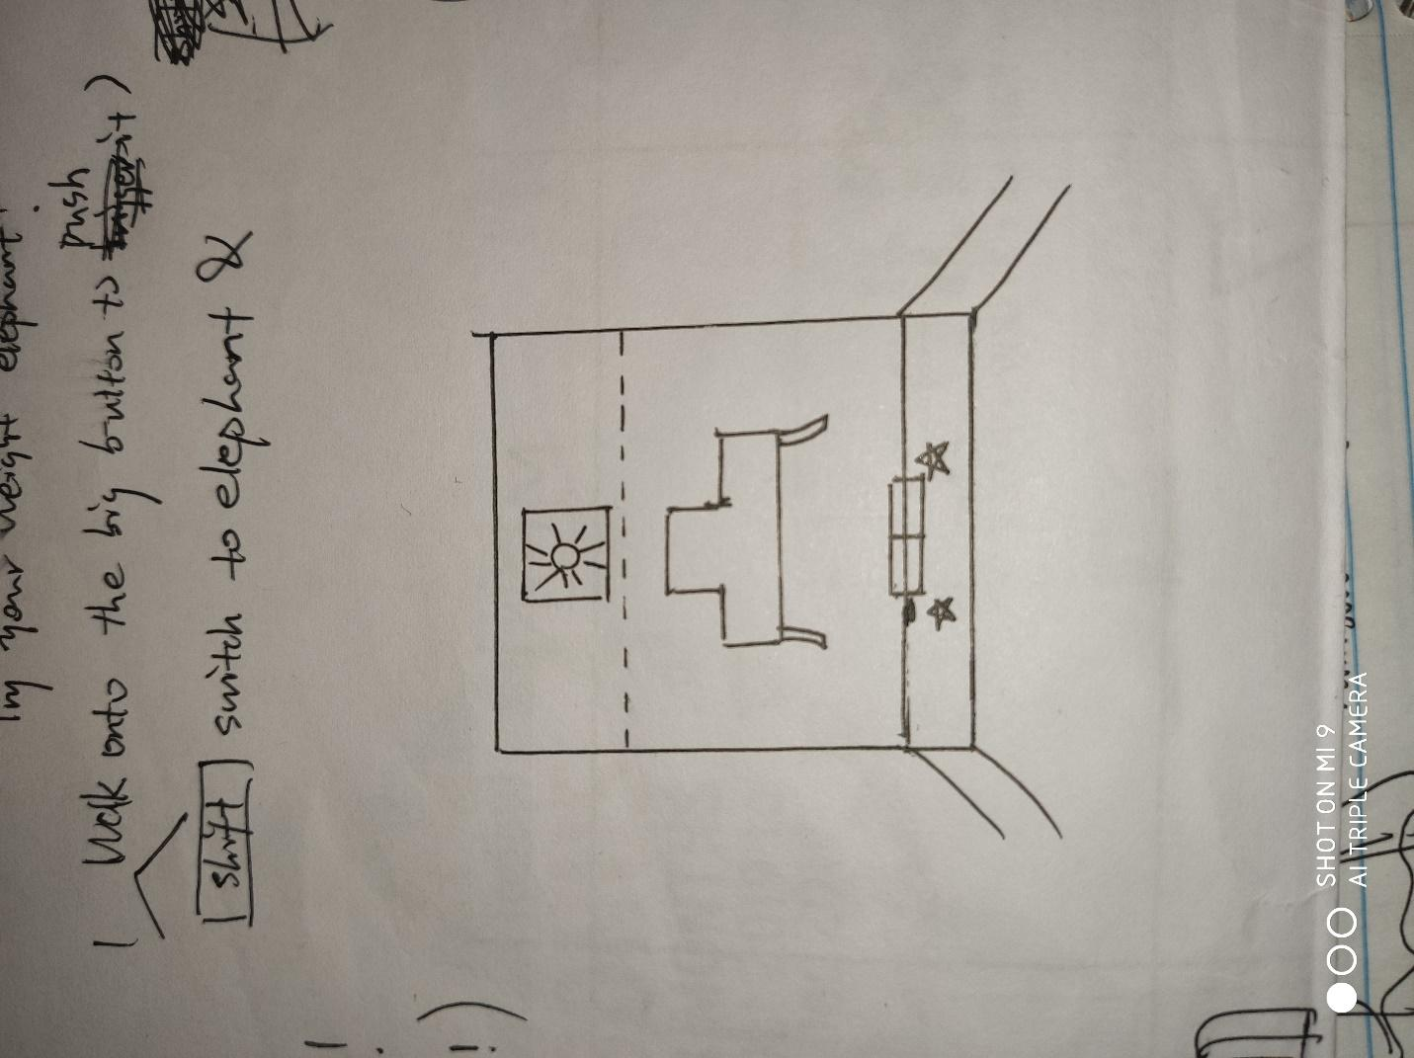

Light Orb Throne

: “Archangel”

Powerful light creatures which guard the door behind them. Players must beat them to open the door.

: ”???”

The final boss of the light side.

Light Orb:

After you defeat the final boss, you can get access to the light orb. Originally you have only one option-destroy the orb. But if you have got enough information and the technique to carry orbs from neutral creatures, you can choose whether to destroy or take the orb. The game will end if you destroy it and play the last scene, otherwise you will return to ground automatically and keep playing.

Art & Aesthetic

**Game World**

It has been ages since the world has seen the sun rise and darkness has taken over the world. The temperature in the world has dropped down severely for the human race to live. All the living things in the world have been corrupted by either the dark or the light. The creatures or things corrupted by the light will have a fantasy look, whereas on the other side, the ones corrupted by dark will have a demonic and dark look. Various areas in the world are too dark for the player to enter unless they have completely turned into a dark monster. The game world is broadly divided into three open world zones that each consist of a light side settlement and a dark side settlement and two minor levels where the artifacts for each side are located. The three zones are very different from each other in terms of art and aesthetics as the zones are separated by levels of darkness.

* Maker’s Choice

The first zone, also called Maker’s choice is the closest to the light artifact and so is the brightest and the most radiant zone in the game world.The City of Literian, the light settlement, is a huge kingdom spread across acres of land and has a lot of NPCs and light sided monsters. The kingdom consists of a castle made of rock that can withstand incredible force to protect the settlement. The shops to buy and sell would be well built as the settlement would be able to sustain themselves as they have all the resources they need. The blacksmith shop in the settlement will have a display of various weapons and tools which the player can look at and learn about. Most of the houses in the city are strong and have medieval-like structures.

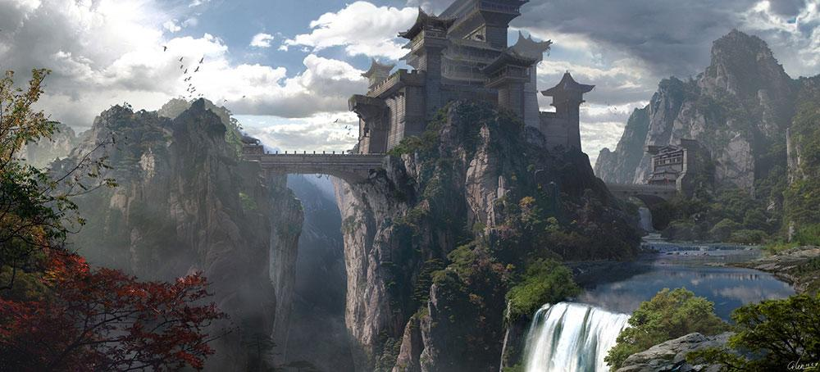

The Lone Somber or the dark settlement in this level is the most vulnerable and the smallest of the dark settlements. The settlement doesn’t have many dark creatures living here since the zone is too bright for some monsters. There would be dark monsters wandering in groups as they feel weaker when they are alone in this zone. The settlement uses the cover of the Cliffs of Raven to defend themselves from the light creatures. The settlement contains makeshift homes that the dark creatures have built for themselves.

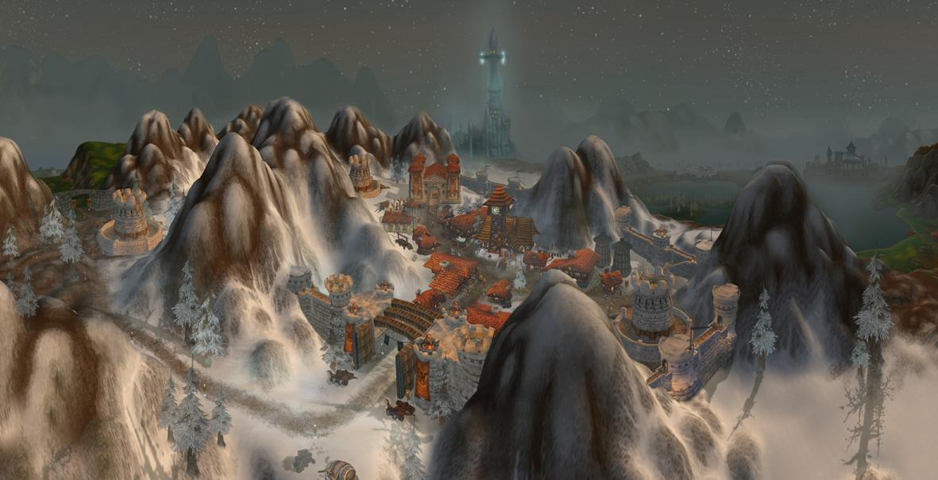

The Volundr Coliseum is the training ground for the light creatures and the creatures training here are some of the most elite fighters on the light side. These light creatures have a collection of various light tools and weapons and the player can choose from them to fight the creatures for experience points. The Coliseum will have a similar structure and mood as the Roman Colosseum with seats in 3 directions for the creatures to have a good time and enjoy the fights.

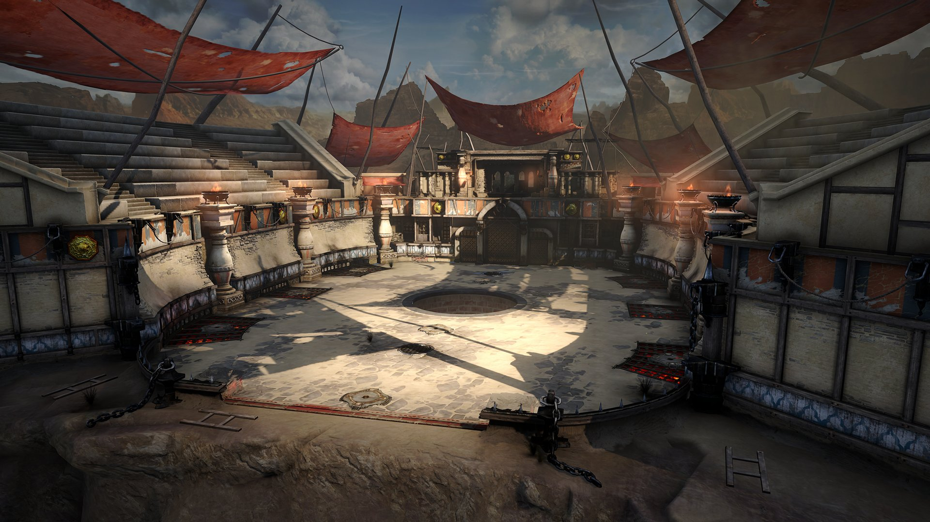

The most beautiful place in the zone, the forbidden falls, are not just regular falls, but have a secret pathway to the dark side of the zone. The falls are surrounded by different minerals and rocks which can enhance the power of the light swords. The creatures have found a huge slit in the mountains of the falls where the player can go through to the other side of the zone. The slit would be having minimal rays of sunlight passing through the waterfalls, making the area dimly lit.

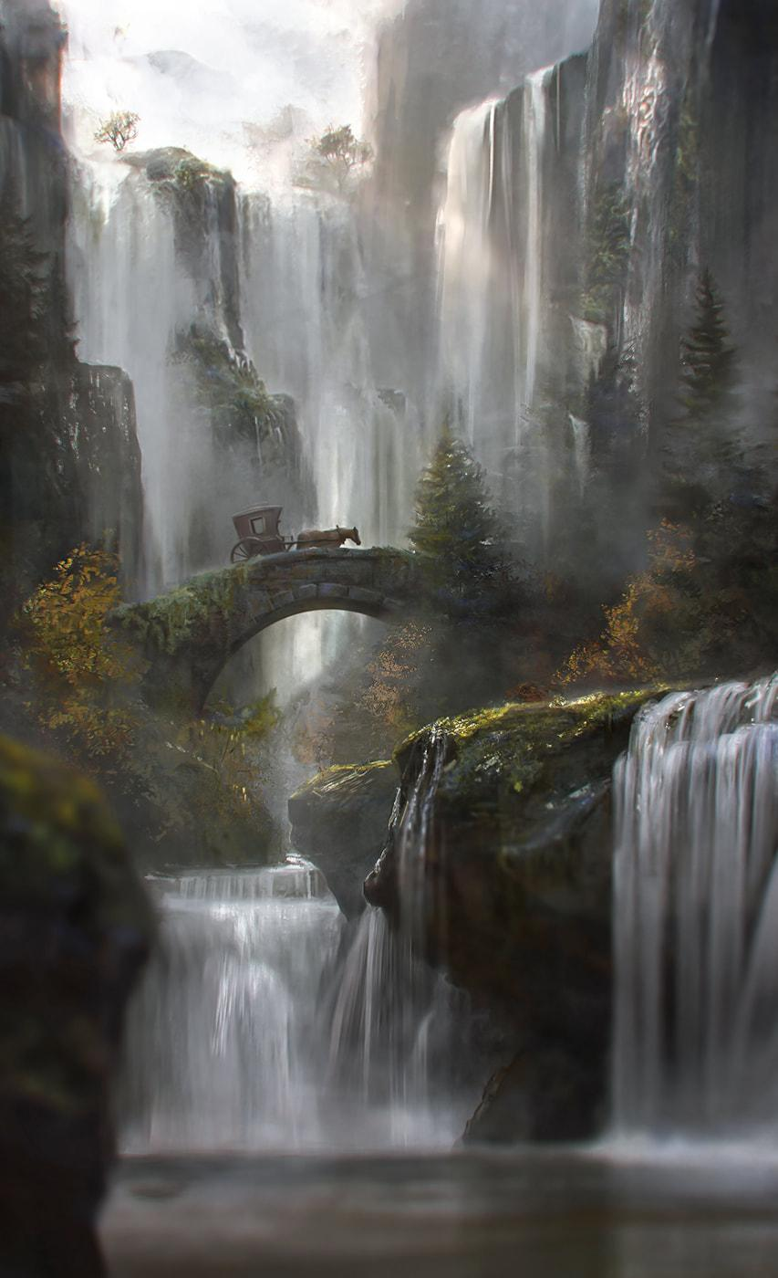

* Vicious Valley

Vicious Valley would have a darker look and feel as compared to Maker’s Choice. The zone will feel like the night has got darker and would have comparatively less Light monster and more dark monsters. The monsters in this zone would have almost the same strength and are in constant war with the other side. The darkness in the zone can affect the player and corrupt them to turn into a monster. The player can feel his environment lighting change as he transforms in the zone. There would be visual transformations like claws and scales on the player if they are getting corrupted by the dark. There would be small caves in the level near the corrupted chasm where dark monsters visit to have a peaceful time. The caves would be immensely dark and cold and have an atmosphere that would be soothing for the dark monsters.

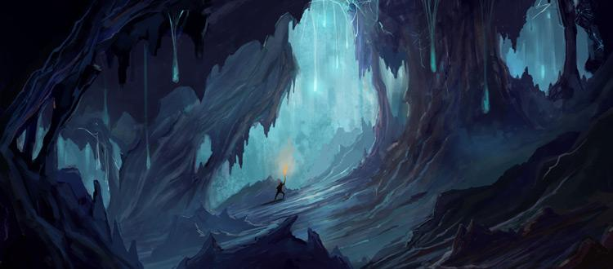

This zone would also consist of neutral remains. These remains will be made of stones or bricks but barely visible due to the dark and the snow covering them and would visually be hinting the player about a neutral ending. The two settlements in the level are divided by a long stretch of snow clad mountains which keeps the two sides safe and far from each other.

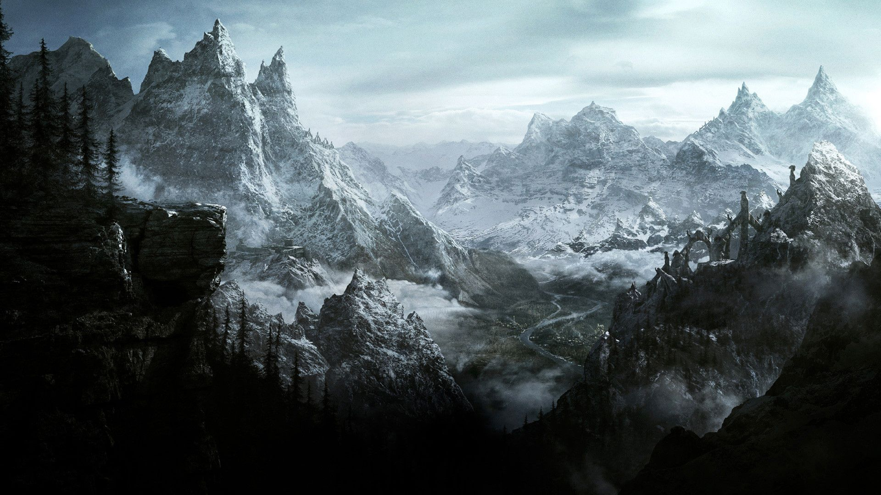

The lake in the zone is the main source of water for the light creatures, so the player would see small groups of light creatures wandering around in the woods near the lake. The are around the lake would be very ambient and have glowing light creatures moving around in the zone. The lake would be a peaceful place as the dark monsters consider it to be a cursed body of water. The lake will look like it is poisoned if the player has completely turned into a monster.

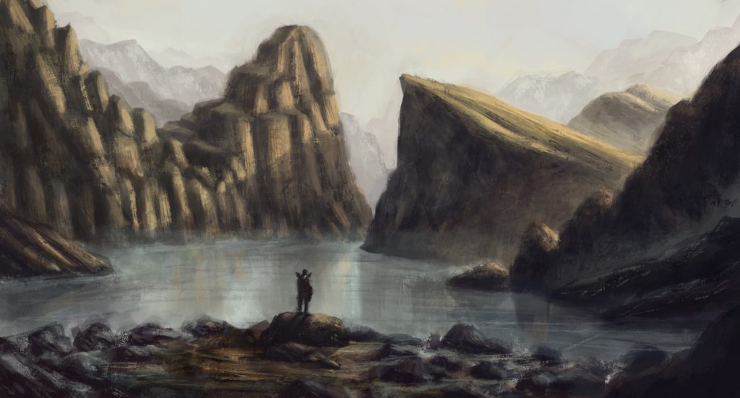

* Ghastly Oblivion

The closest to and the most corrupted zone by the dark artifact, Ghastly Oblivion will have around little to no light creatures in the zone. The dark creatures would be more hostile to any character that emits light in this zone as the creatures are not used to any source of light ruin their habitat. The zone will be completely filled with little amount of snow and have multiple dark type NPCs. The light settlement at the base of the canyon will have small tents and bonfires outside to give the light creatures warmth in the cold night. The Manticore will have platforms of sand standing up in the valley which will have flying dark monsters land on them and hit the player. The sand and rock platforms will also break and fall if the player stays too long on them fighting his enemies.

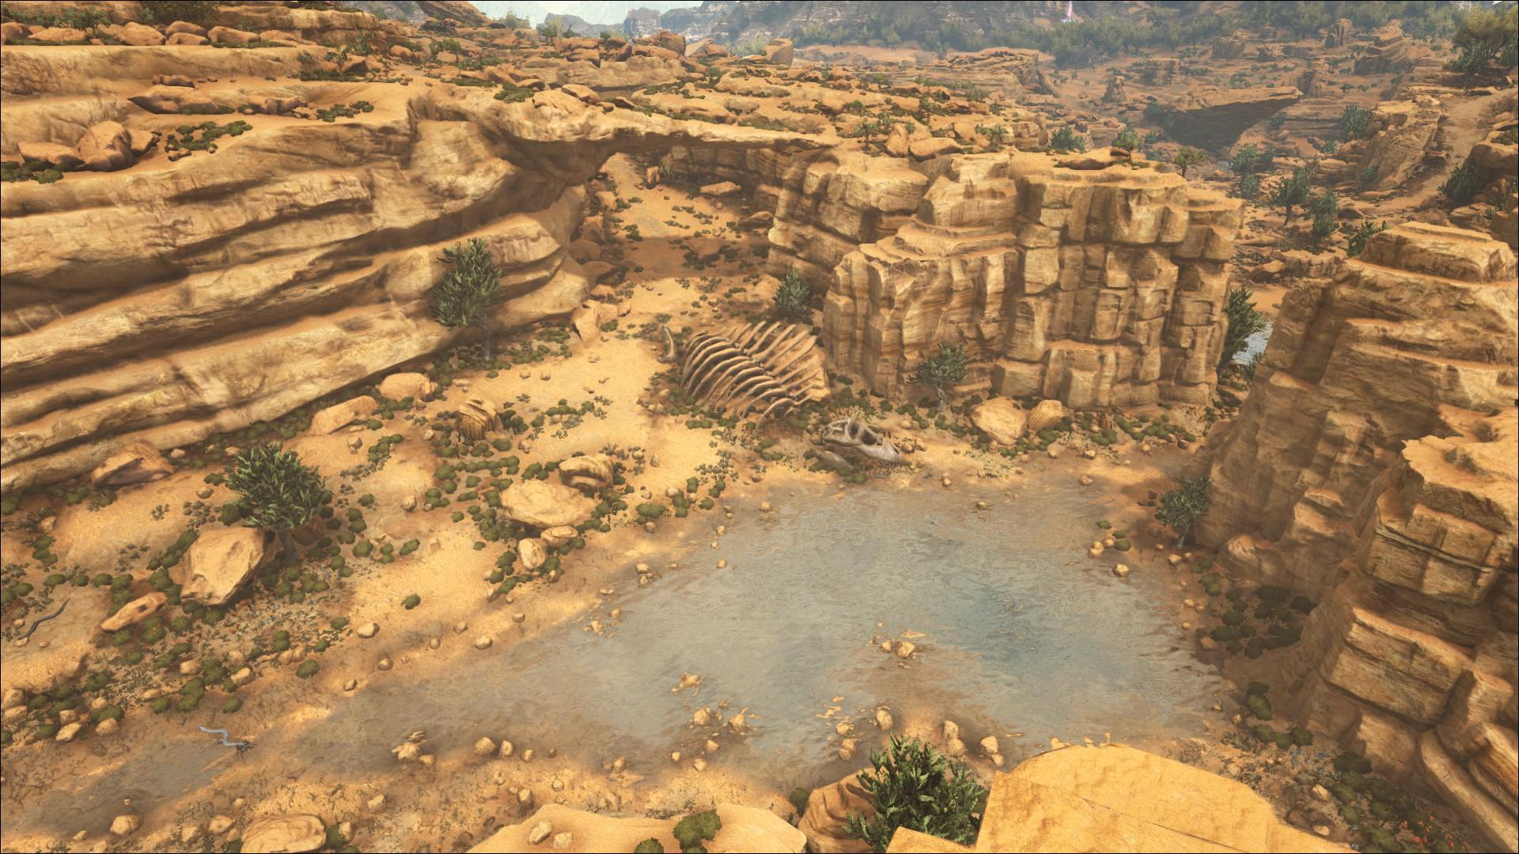

The settlements will be divided by a long stretch of dense forest that if filled with new and dangerous dark creatures. There would be various healing trees in the forest which would secrete gum that the player can use to heal themselves. There would be many side quests in the forests that open up by a portal which takes us to a cave.

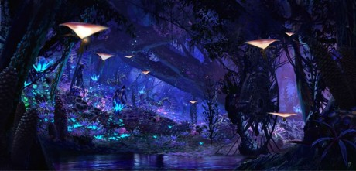

The cave would have high ceilings with water till calf height and huge murals on the walls. The player would have to look through them and find out the history about the artifacts and know how to destroy both of them. The murals on the walls would not be clearly visible but visible enough to put the idea through.

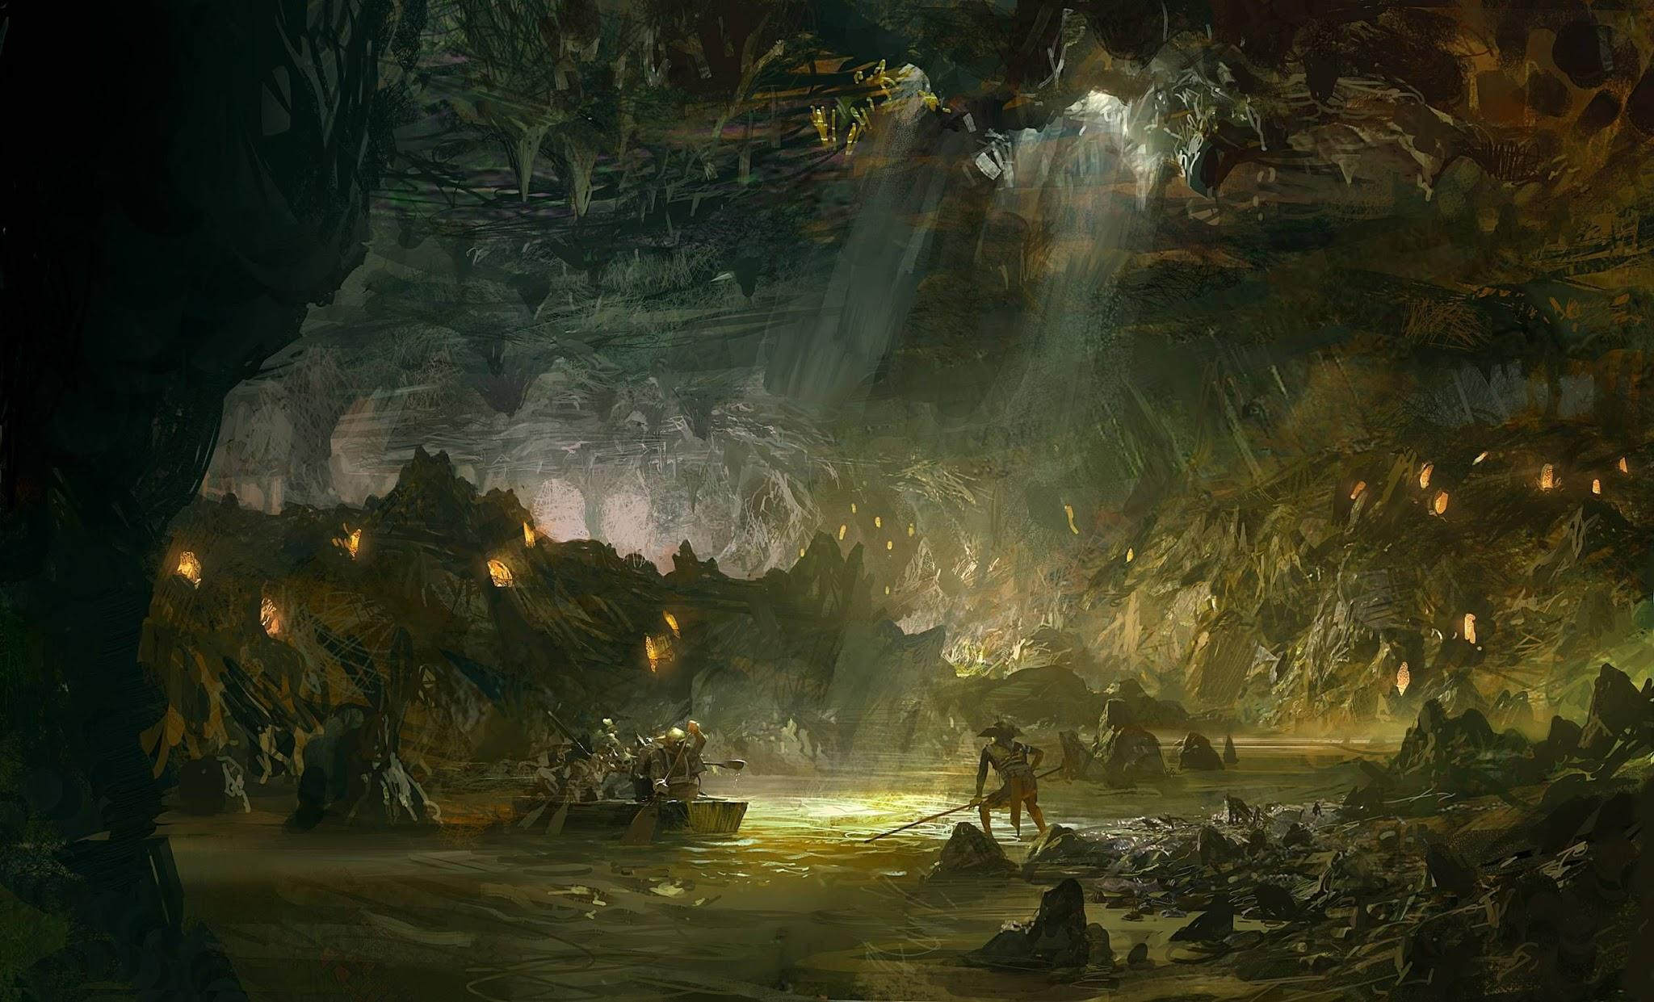

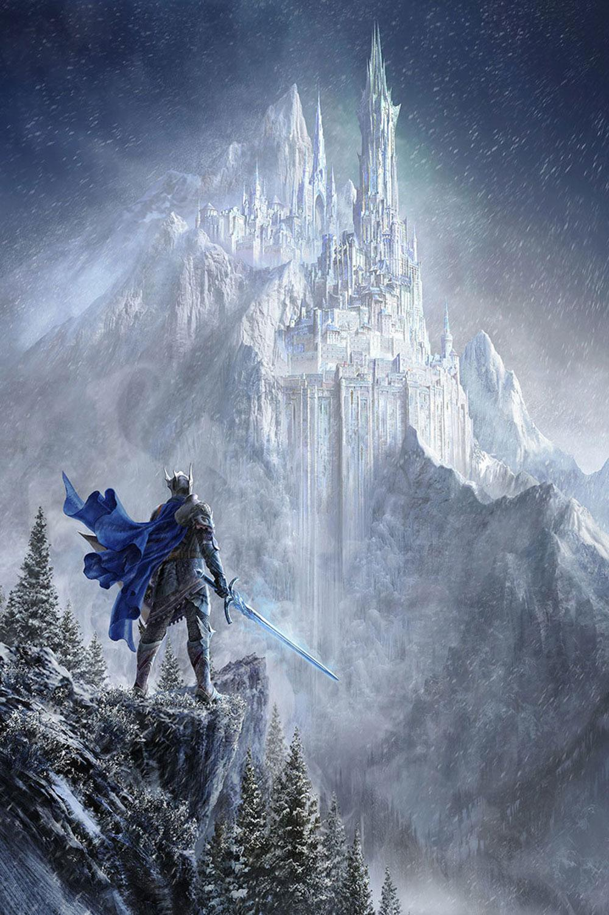

The fort Ecraycey, the dark settlement, is the home of the strongest dark boss and is located on top of a mountain. The fort is made of marble which helps to keep the place cold. The fort is heavily guarded by dark creatures of all types and the player can see dragons and wyverns flying over the fort that pierces the clouds. There would be lightning all over the place to create a scary vibe to intimidate the players. The fort will have NPC’s wandering around and and guards at places where the player would have to sneak in to kill the dark boss.

**Characters:**

NPCs

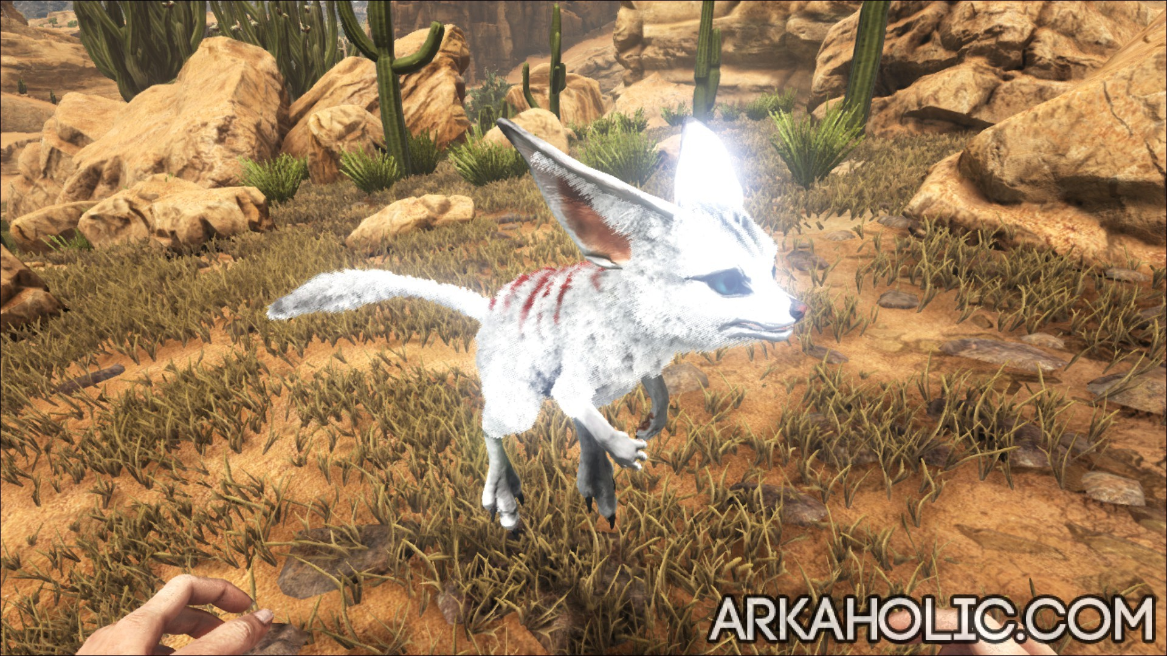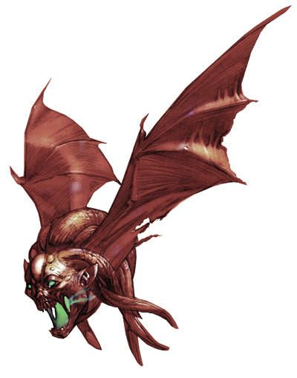

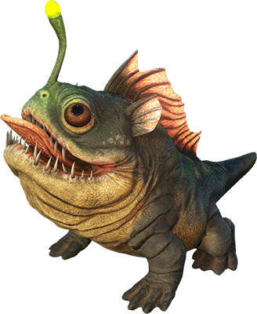

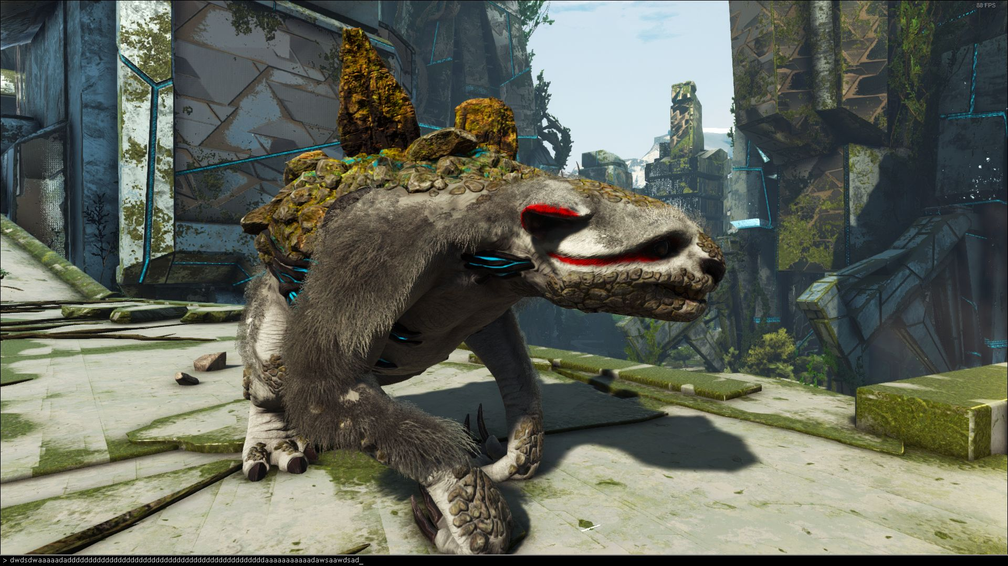

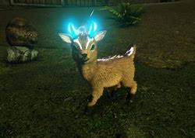

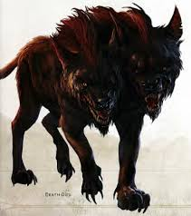

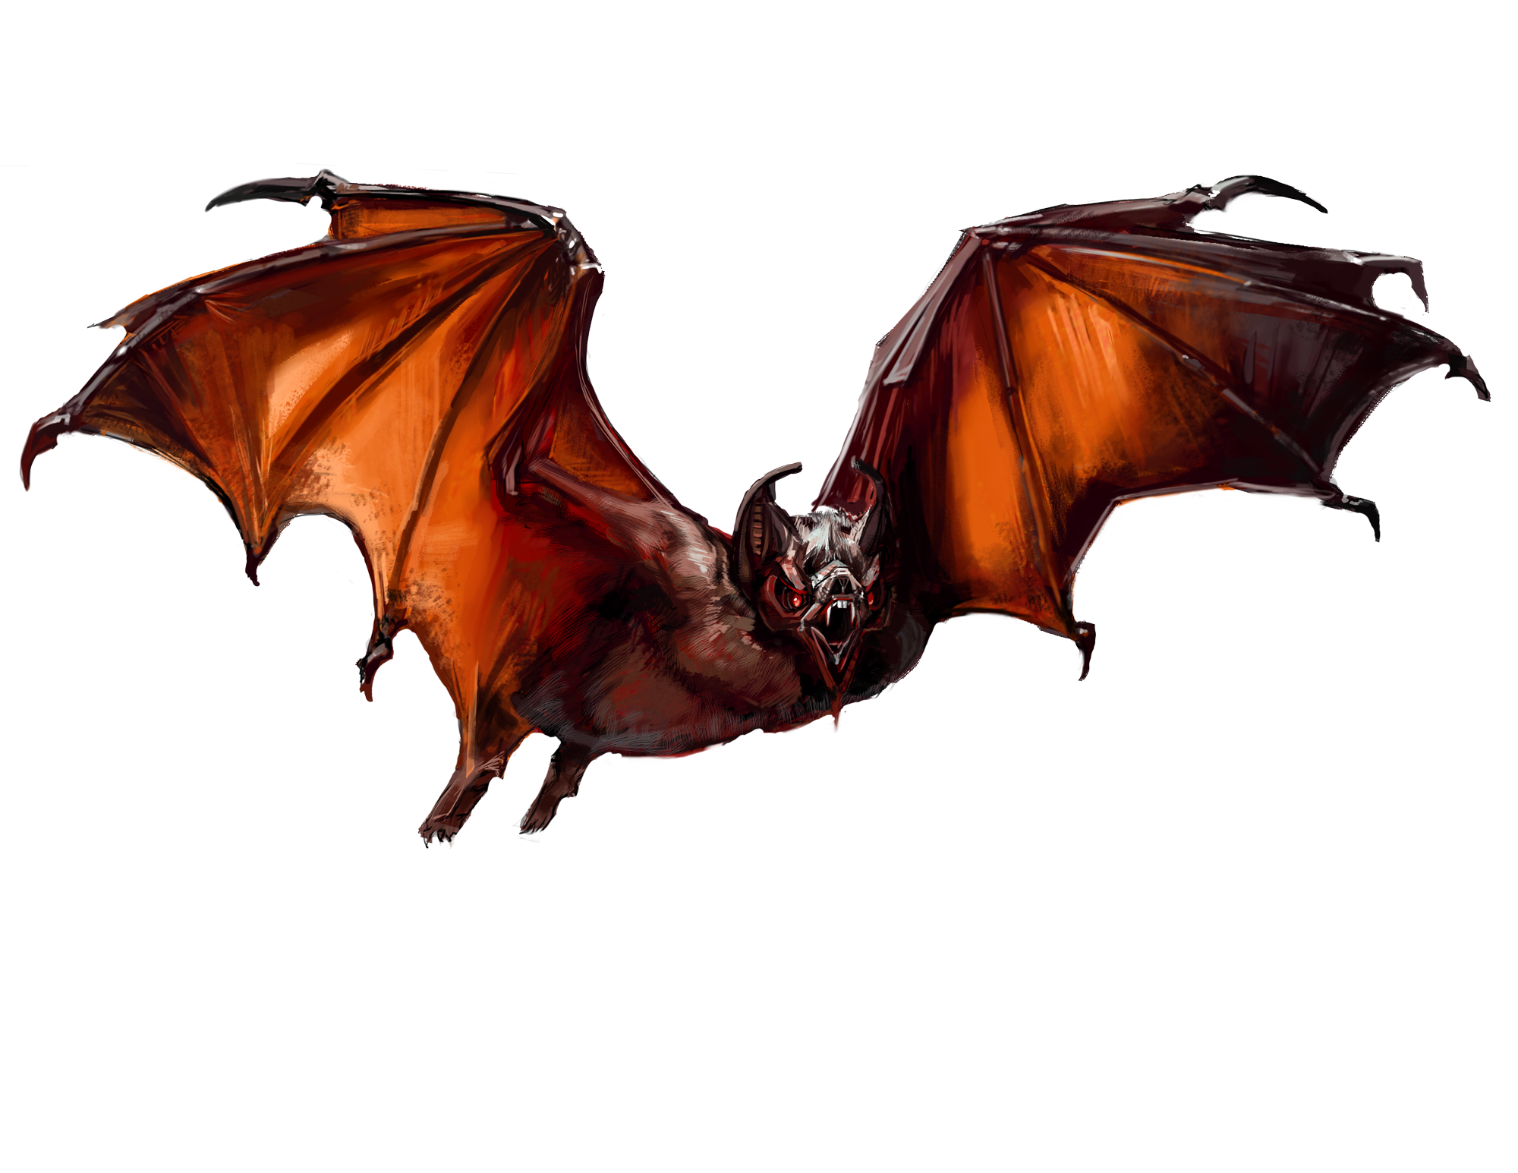

**Enemies:**

Zone1:

Claunch: Resembles that of a hairless goblin like rat with a disfigured posture nad deep claws and teeth. Uses their tail to balance and attack with great force.

Bono: Vicious apes, which are terrifying creatures having huge fists which they can use to decimate their opponents.

Geefog: Resembles a rat with porcupine quills protruding from its back which can be released in different directions to deal damage.

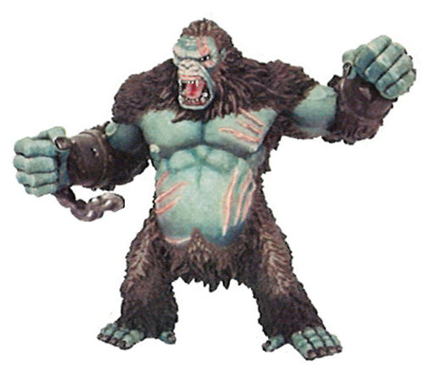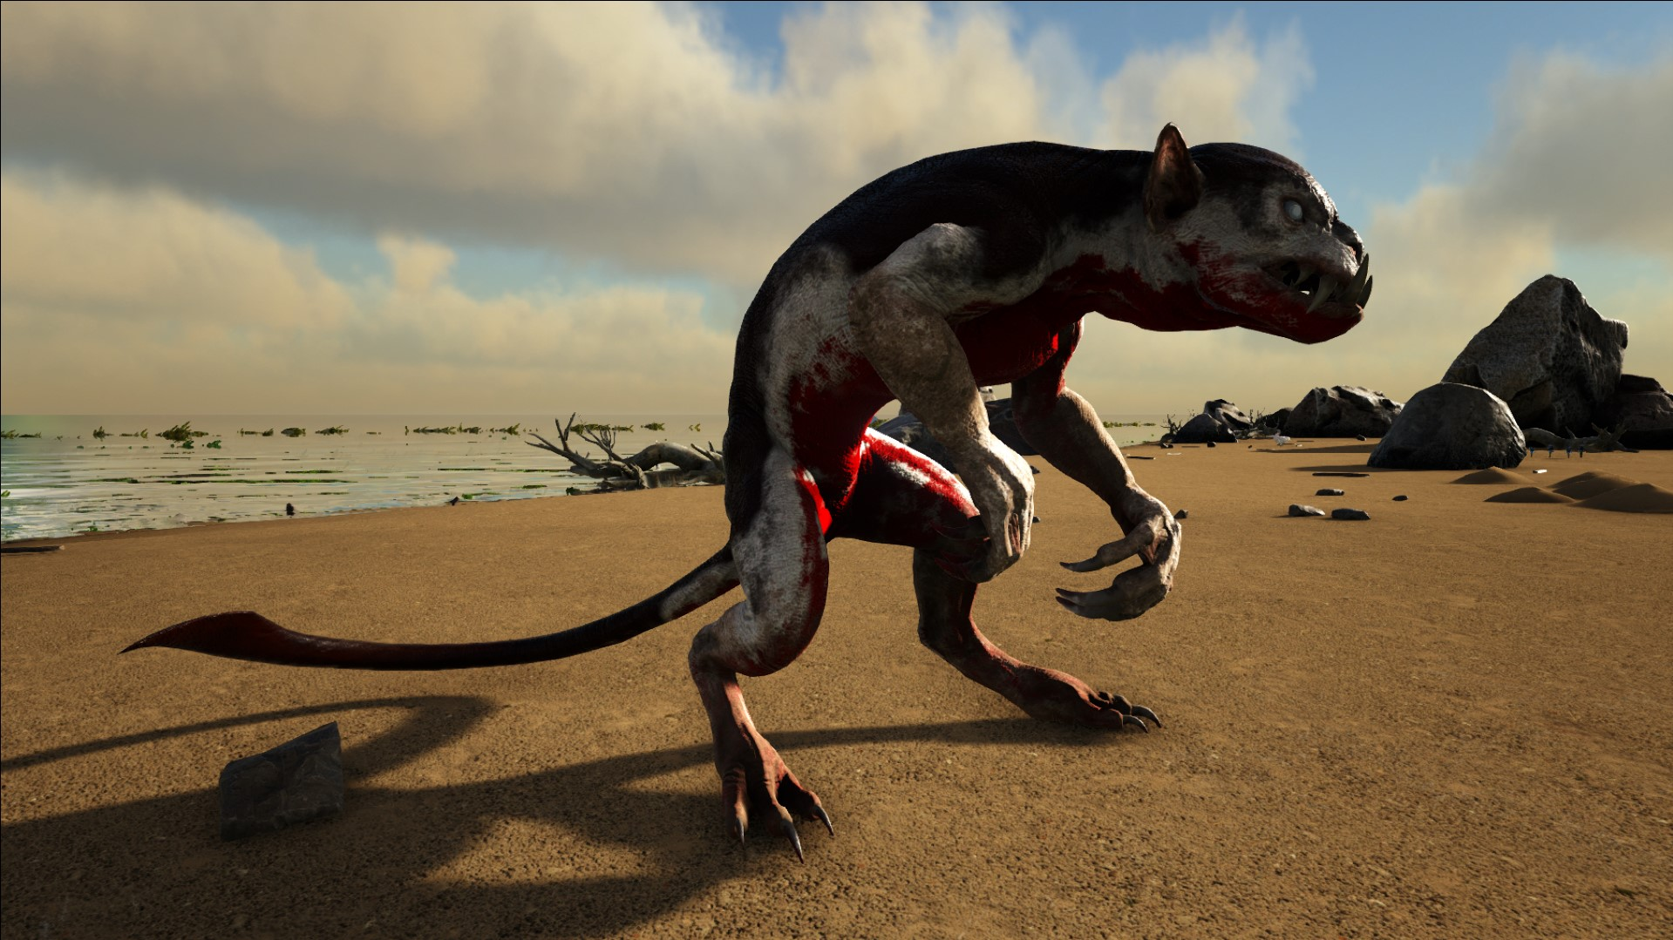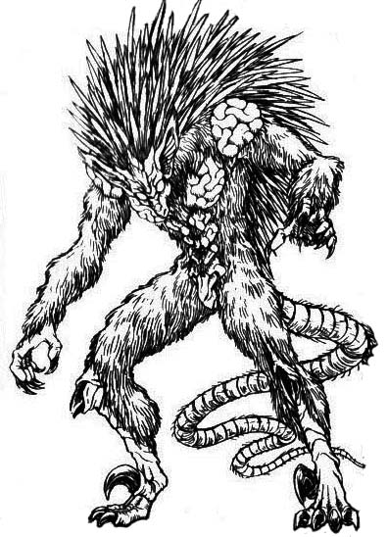

Zone 2:

Deathworm: Looks like a regular deathworm but are huge in size with deadly claws instead of appendages and can dig underground and attack to deal damage.

Jera: A dangerous mammal with a hard exoskeleton and the ability to strike thunder in a particular direction

Grobo: A huge titan with immense power that grabs their opponent and throws them.

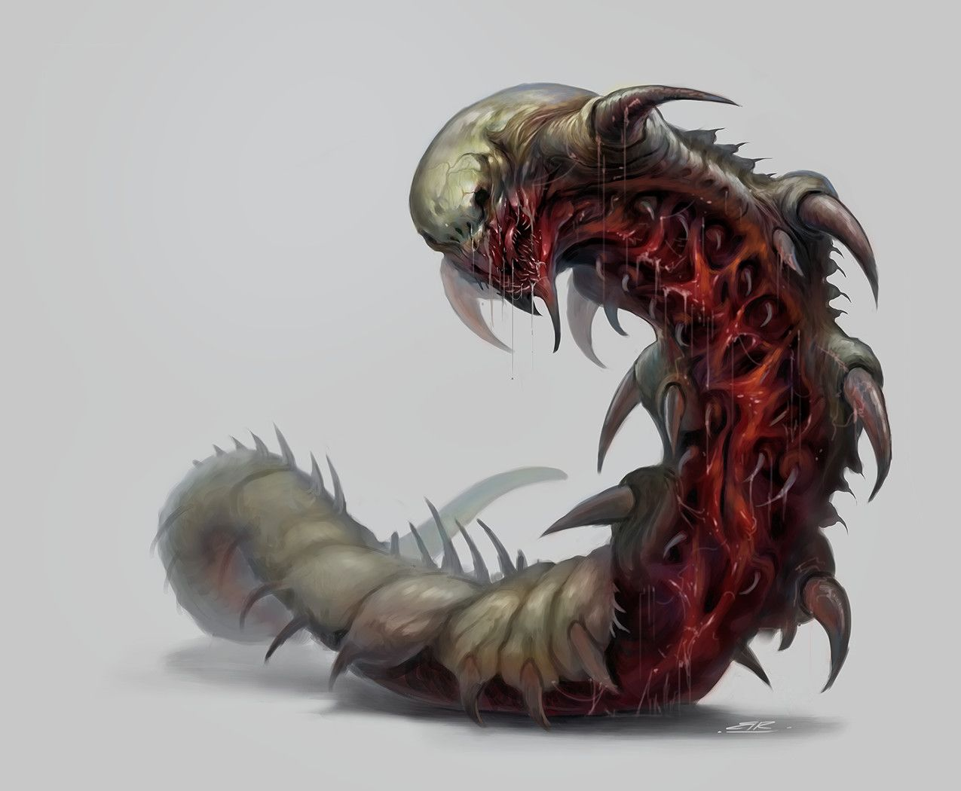

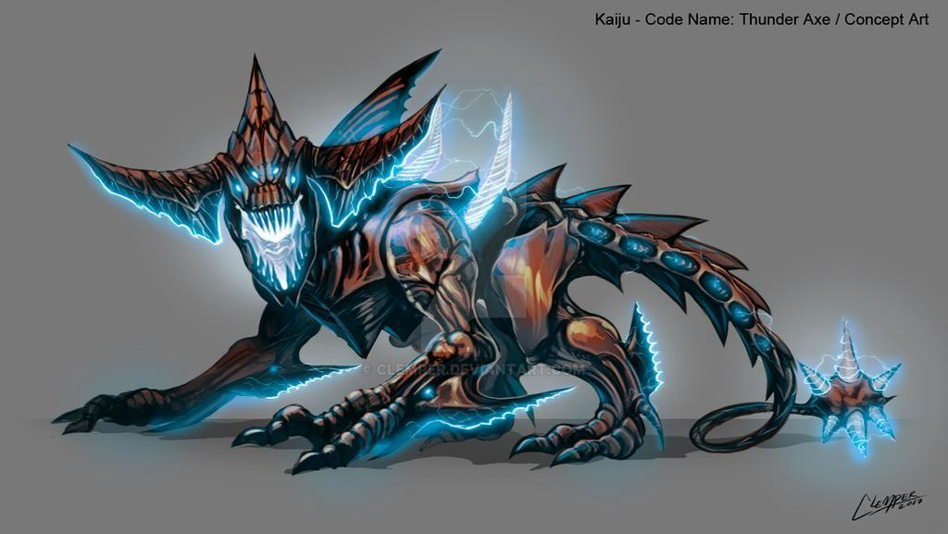 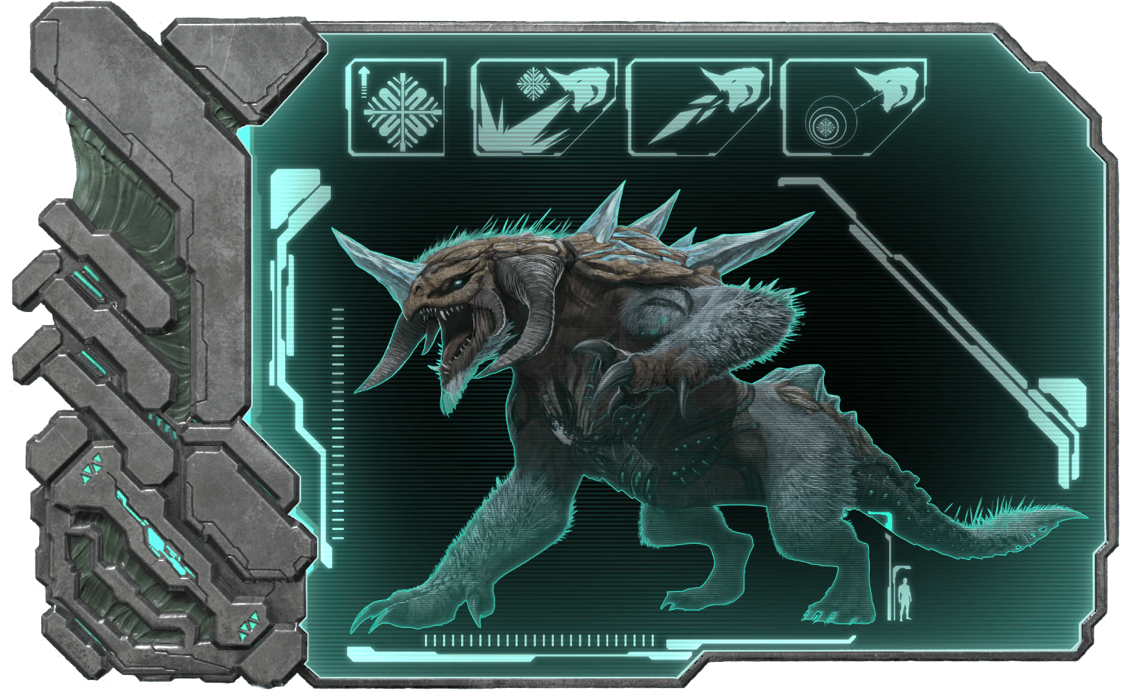

Zone 3:

Seeker: The Seeker is a small winged creature that has small, bird-like legs that hang off the ground underneath the creature's body while using its bat-like wings to walk.

Gibber: Monster made of a mound of flesh full of eyes and mouths and can create monsters by splitting self into half.

Coorb: A mutant of sand and wind that uses orbs to attack which are revolving around its body.

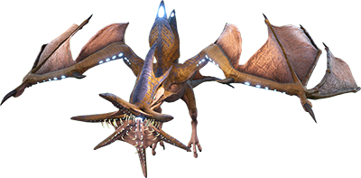

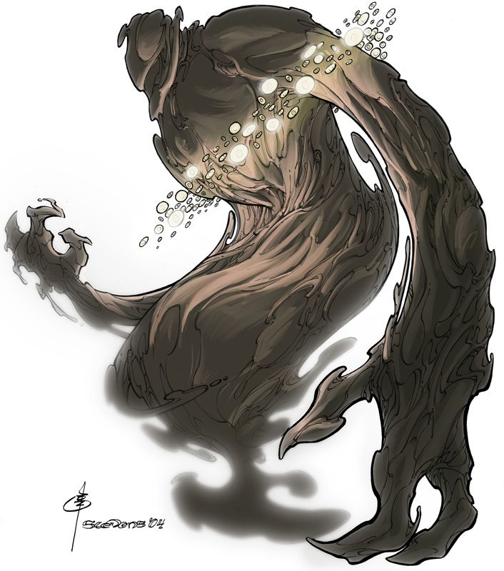

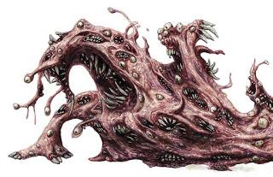

**Transformation:**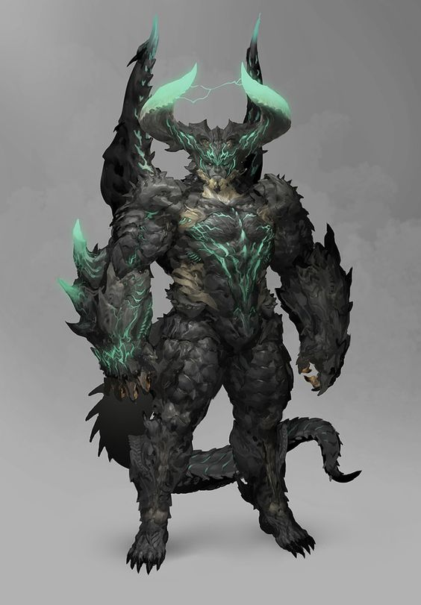

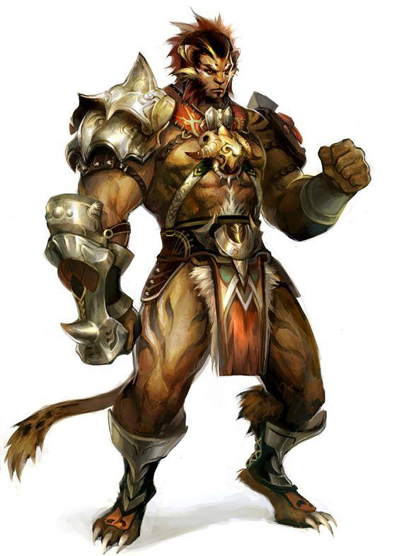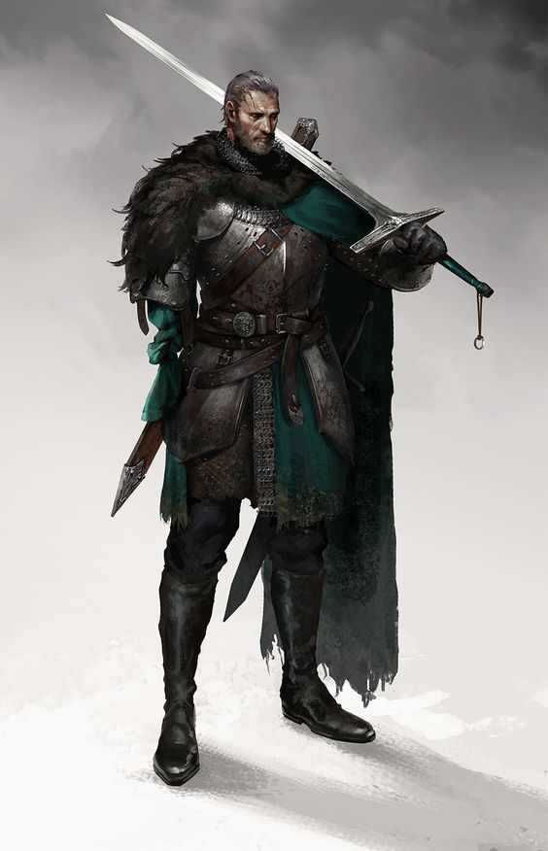

**Items:**

Swords

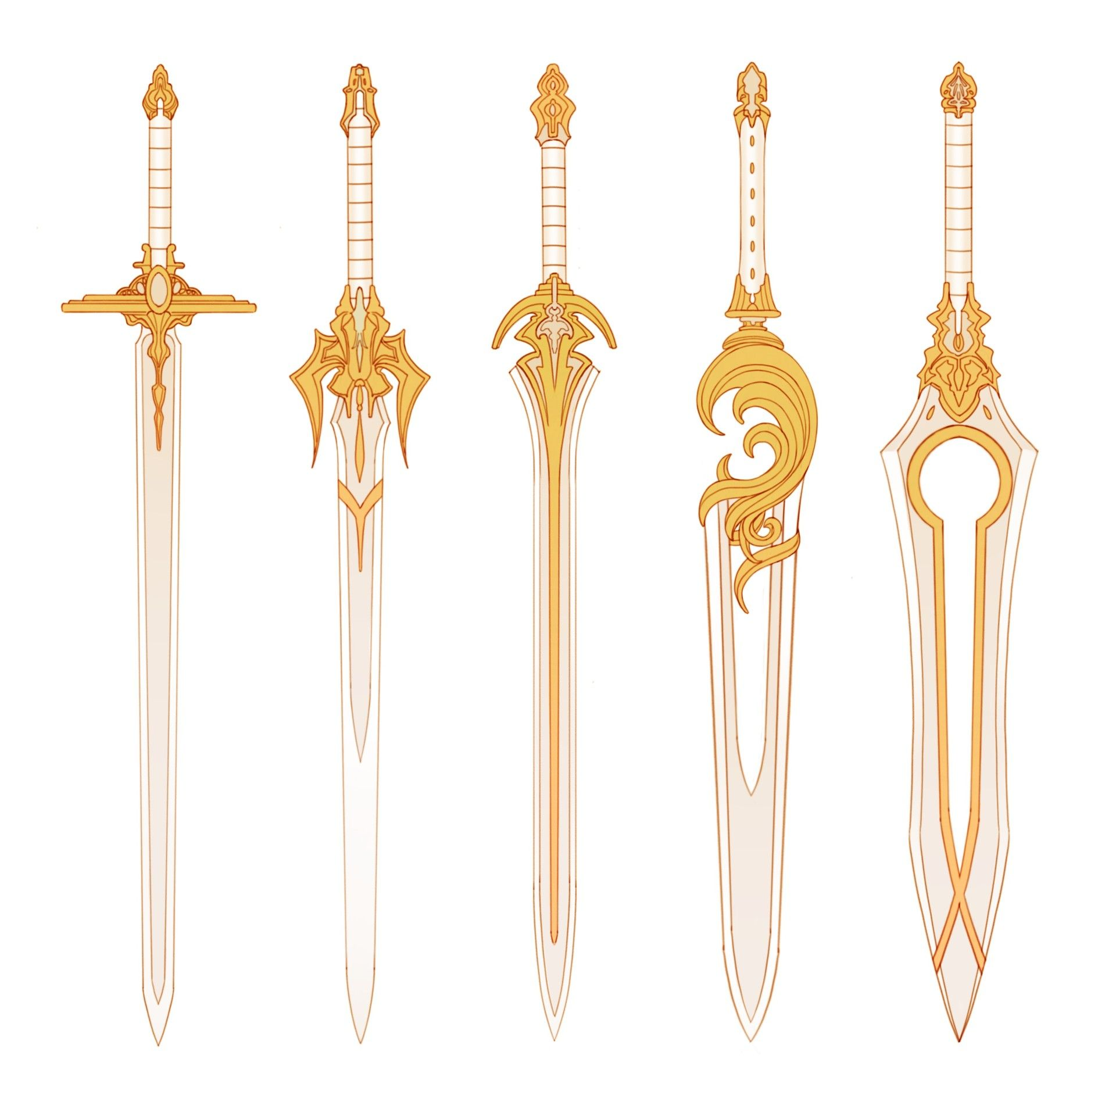

Links for images

1. <https://www.designyourway.net/blog/wp-content/uploads/2009/12/Fantasy-Castles-7.jpg>
2. <https://vignette.wikia.nocookie.net/the-lions-call/images/9/9f/Old_Alterac.jpg/revision/latest?cb=20130110171904>
3. <http://www.jordigart.com/uploads/1/0/9/0/109046277/14032015-waterfall_1.jpg>
4. <https://www.designyourway.net/blog/inspiration/digital-art/fantasy-digital-paintings-of-castles-40-examples/attachment/fantasy-castles-20/>
5. <https://i.pinimg.com/originals/4a/f5/2b/4af52bf0b41de3405a921fdcdfd10c5f.jpg>
6. <http://dawidchachulski.com/wp-content/uploads/2017/05/6-1024x551.jpg>
7. <https://steamuserimages-a.akamaihd.net/ugc/960851554634599987/95F785ED304DB5FC7231161BAC6E132A447074E5/>
8. <https://ark.gamepedia.com/Central_Canyons_(Scorched_Earth)#/media/File:Central_Canyons_(Scorched_Earth).jpg>
9. <https://www.deviantart.com/clemper/art/Kaiju-Thunder-Axe-699070968>
10. <https://gamepedia.cursecdn.com/arksurvivalevolved_gamepedia/d/d3/Dossier_Ice_Titan.png>
11. <https://in.pinterest.com/pin/547117054730104480/?lp=true>
12. <https://www.dododex.com/media/creature/seeker.png>
13. <https://2.bp.blogspot.com/-iuaWx4CASnU/VxZGIyro0FI/AAAAAAAADx0/aXLrp73JhRIKNyPUDHfiz_-3CojRm8PVgCLcB/s320/gibbering.jpg>
14. <https://i.pinimg.com/originals/3b/a4/fe/3ba4fe2f65e3389ab12b9f975d772279.jpg>
15. <http://arkaholic.com/wp-content/uploads/2017/02/Jerboa.jpg>
16. <https://i.pinimg.com/originals/59/0d/ee/590deeb0b5a84ccfb5466a643b134df4.png>
17. <https://gamepedia.cursecdn.com/arksurvivalevolved_gamepedia/5/5d/Gacha_PaintRegion3.jpg>
18. <https://i.pinimg.com/originals/e5/0b/f0/e50bf05e4898becaa9cfece21daba29e.png>
19. <https://encrypted-tbn0.gstatic.com/images?q=tbn%3AANd9GcTPnSl4Evs2y9Ol5s8TOv3BzHpJKT7vhOxWgYVQsPCZzbXW5qYx>
20. <https://i.pinimg.com/originals/d8/ff/38/d8ff388819398947fa3dda96bf715379.jpg>
21. <https://www.artstation.com/artwork/lVDvEk>
22. <https://i.pinimg.com/564x/d3/28/b3/d328b32c617c80a4ad32fa1b0a7c9f23.jpg>
23. <https://i.pinimg.com/564x/1f/3b/23/1f3b234625ff21c6d73a41a248e1b842.jpg>